*Florida International University*

*School of Computing and Information Sciences*

CIS 4911 - Senior Capstone Project

Software Engineering Focus

Final Deliverable

BOLO Flier Creator Version 6

**Team Members:**

Dominick Martelly

Brian Zamora

**Product Owner(s)**:

Samuel Ceballos

Jason Cohen

**Instructor**: Masoud Sadjadi

The MIT License (MIT)

Copyright (c) *2016*

Permission is hereby granted, free of charge, to any person obtaining a copy of this software and associated documentation files (the "Software"), to deal in the Software without restriction, including without limitation the rights to use, copy, modify, merge, publish, distribute, sublicense, and/or sell copies of the Software, and to permit persons to whom the Software is furnished to do so, subject to the following conditions:

The above copyright notice and this permission notice shall be included in all copies or substantial portions of the Software.

THE SOFTWARE IS PROVIDED "AS IS", WITHOUT WARRANTY OF ANY KIND, EXPRESS OR IMPLIED, INCLUDING BUT NOT LIMITED TO THE WARRANTIES OF MERCHANTABILITY, FITNESS FOR A PARTICULAR PURPOSE AND NONINFRINGEMENT. IN NO EVENT SHALL THE AUTHORS OR COPYRIGHT HOLDERS BE LIABLE FOR ANY CLAIM, DAMAGES OR OTHER LIABILITY, WHETHER IN AN ACTION OF CONTRACT, TORT OR OTHERWISE, ARISING FROM, OUT OF OR IN CONNECTION WITH THE SOFTWARE OR THE USE OR OTHER DEALINGS IN THE SOFTWARE.

***Abstract***

*The Pinecrest Police Department wish to bring policing into the future by combining technology with their vast domain knowledge. The current system for the distribution of BOLO's is insecure. For these reasons the Pinecrest Police department has employed the assistance of the college of engineering and computer science at Florida International University implement their innovative idea.*

*This document is a repertoire of the BOLO* ***Version 6.0*** *system, a user-driven approach that allows law enforcement agents to instantly publish BOLOs. This document contains an extensive list of implemented user stories. It also provides a detailed plan of execution that includes hardware and software specifications. System design is explained through specific diagrams. System validation is also discussed. A glossary with essential domain terminology can also be found. Finally, the last chapter contains a series of appendices with UML samples, screenshots, and progress reports.*

Table of Contents

Introduction 6

Current System 6

Purpose of New System 6

Implemented User Stories 7

Sprint 1 7

Sprint 2 7

Sprint 3 8

Sprint 4 8

Sprint 5 9

Sprint 6 10

Project Plan 11

Hardware and Software Resources 11

Development Environment 11

Deployment Requirements 11

Sprints Plan 12

Sprint 1 12

Sprint 2 14

Sprint 3 16

Sprint 4 17

Sprint 5 21

Sprint 6 24

System Design 26

Architectural Patterns 26

System and Subsystem Decomposition 26

Deployment Diagram 27

Design Patterns 28

System Validation 29

Glossary 34

Appendix 35

Appendix A – UML Diagrams 35

Static UML Diagrams 35

Dynamic UML Diagrams 62

Appendix B – User Interface Design 88

Appendix C – Sprint Review Reports 107

Appendix D – Other Documents 119

References 123

# Introduction

“BOLO Flyer Creator” is a web application that allows police officials of Pinecrest police agency and others to distribute and receive BOLOs (Be on the Lookout) flyers on the web. This is so that other officials in the surrounding areas can share local information quickly and securely to each other. This is meant to enhance the current system, which uses the following strategies to create and disseminate BOLOs: alerts over police radio, computer-aided dispatch that is dependent on antiquated hardware, and paper printed posters for manual distribution.

## Current System

The current approach used by Pinecrest Police Department to create BOLO flyers is insecure. The web server is hosted on IBM’s Bluemix originally due to their uptime and largely expandable servers. Unfortunately, due to the confidentiality that cannot be guaranteed from the passing of confidential information to non-police-conformant servers, IBM’s servers can no longer be used to host the application.

Excluding the confidentiality, the system is too dependent on the use of programmers to add functionality instead of supervisors to the ever evolving world of crime. There needs to be a way for officers and administrators to create new fields when a new type of crime occurs.

## Purpose of New System

BOLO Flyer Creator 6.0 was designed to change the databased used for the application, and implement expandable categories for BOLOs.

The change of the database will allow the web application to be installed on a private server where the system operator will have full control of the system. This will ensure security and confidentiality if the information passed between other officers.

The expandable categories will now free the limits on what gets reported on the field in the future. If a crime or report needs to be created, but the form is not on the system, administrators can create new category forms so that the user can share valuable information. The system is essentially future proof since the new categories are stored on the database.

Other implementations were also completed on the system, including, but not limited to Agency removal, password conformation, and webpage editing.

# Implemented User Stories

This is a list of the user stories that were implemented for version 6 of BOLO. All the user stories compiled here were requested by the product owner, Jason Cohen.

### Sprint 1

(08/27/2016 - 09/09/2016)

**User Story #1177** All pictures are viewed on the bolo-details view

* As a user, I can view all the pictures for a selected BOLO on a ViewSelectedBOLO Page

**User Story #1179** Allow batch upload of excel document for new users

* As an admin, I can upload an excel file of new users, so that they can be added into the system

**User Story #1186** New User Button

* As an admin, I want the create new user button to always be readily available, so that I don’t have to scroll all the way to the bottom of the page to create a new user.

**User Story #1187** Generated watermark on completed BOLOs

* As an officer, I want a watermark to be rendered when a BOLO is marked as completed, so that it is made clear which BOLOs are still pending and which ones are completed.

### Sprint 2

(09/10/2016 - 09/23/2016)

**User Story #1182** Allow root user to edit the “About Us” Page

* As a root user, I want to be able to edit the “About Us” page, so that changes can be made in the future if necessary

**User Story #1183** Allow root to edit the “Login” page

* As a root user, I want to be able to edit the “Login” page, so that changes can be made in the future if it is necessary

**User Story #1184** Allow root to edit the “User Guide” page

* As a root user, I want to be able to edit the “User Guide” page, so that changes can be made in the future if it is necessary

**User Story #1189** Agency Specific BOLO

* As an officer I want to be able to view BOLO fliers specific to my department, so that I can see what BOLO fliers are active in my area

**User Story #1190** Agency Specific View

* As an officer I want to be able to create an internal BOLO flier, specific to my department so that other officers in my department can see what is going on in our local area

### Sprint 3

(09/24/2016 – 10/07/2016)

**User Story #1191** Email PDF Privacy

* As an officer I want the details of a BOLO flier to be kept to a minimum when being emailed, so that no one except those that have access to the BOLO application can have specifics about the flier

**User Story #1194** BOLO Category Template Creation

* As an administrator or root user, I want to be able to create a new template for a BOLO, so that the BOLO system can adapt based on the needs of the police department.

**User Story #1196** BOLO Template Rendering

* As a user, I want to be able to select the category of the BOLO template that I want to fill out, so that from one single page I can load any template that I need, instead of having a separate static view for each category.

### Sprint 4

(10/08/2016 – 10/21/2016)

**User Story #700** Delete Agency

* As root, I can delete an Agency from the database as well as all users associated with the agency, so that I can better manage the BOLO web application.

**User Story #1188** Convert Web Application Database to MongoDB

* As a root, I can install the BOLO web application on a server that can run MongoDB, so that the web application can be run on a secure server.

**User Story #1192** Delete User

* As a root user or an administrative user, I want to be able to delete a user from the database, so that I can better manage the BOLO web application.

**User Story #1195** Adjust CSV Uploading to use MongoDB

* As a root/administrator user, I want to be able to upload a csv user, so that I can upload more than one user at a time into the BOLO system.

**User Story #1197** Email Confirmation for BOLO creation

* As a user, I want to receive an email notification when a new BOLO is created so that I can confirm that I want the BOLO to be posted.

**User Story #1198** Adjust BOLO View

* As a user I want to have a central location to view all BOLO fliers that were created, so that I can view them at any time.

**User Story #1199** Adjust PDF Rendering for MongoDB

* As a user I want to be able to create a PDF of a BOLO, so that I can easily print and distribute them if needed.

**User Story #1200** Adjust PDF Email Privacy for MongoDB

* As an officer I only want to see a portion of the BOLO in my email, so that eavesdroppers can’t get full BOLO details from my email.

### Sprint 5

(10/22/2016 – 11/04/2016)

**User Story #1180** Set Password

* As a new user, I can immediately change my password when I first login to my BOLO account, so that no one knows my password except me.

**User Story #1193** BOLO Image Compression

* As a user, all photos uploaded as an image to my BOLO flier is compressed so the database will not fill its storage quickly

**User Story #1202** BOLO Image Resizing

* As a user I want the images to be resized based on how many images are present on the BOLO, so that the pictures are always very prominent and as large as they can be.

**User Story #1204** Data Analysis

* As a root/administrator user, I want to be able to pull data for my agency in a CSV form, so that I can quickly see what kind of bolos are created by agency as well as the details of the BOLOs.

**User Story #1206** New User Notification

* As a root/administrator, I want that a new user gets an email notification when a BOLO account is made for them, so that they can begin using the BOLO system right away.

### Sprint 6

(11/05/2016 – 11/11/2016)

**User Story #1201** BOLO Data Subscriber

* As a user, I can subscribe to a particular BOLO so that I will be updated if the status of a subscribed BOLO changes

**User Story #1205** BOLO Password Verification

* As a root/administrator, I want to make sure that all users are following the password strength requirements, so that the BOLO web application can only be accessed to those that are authorized to access it.

# Project Plan

The project was done using agile development where project members had sprint meeting five days of the week. A meeting with the product owner occurs every Friday and sprints last bi-weekly.

Below are the recommended hardware specifications as well as the required software needed to run the application from a developer’s point of view.

The plans for each sprint is also listed. The details for each sprint includes the requirements, related tasks, and references.

## Hardware and Software Resources

In order to develop and deploy the application some hardware and software is required. The following sections will describe the environments needed.

### Development Environment

In order to develop the application, the follow hardware specs are recommended:

* Windows/Apple Computer
* Min of 4Gb of RAM
* At least 30 GB of disk space
* At least 2.0 GHZ processor

For software development, developers are recommended to have working knowledge of the following:

* HTML 5 / CSS 3
* JavaScript (ECMAScript 6)
* Pug (previously known as Jade) templating for HTML
* Node.js 4.2+
* NPM (NPM is the package manager for node.js. It is used to install project dependencies as well as to automate the execution of the application testing and miscellaneous scripts)
* Express Framework (Express is a minimal and flexible Node.js dependency that provides a robust set of features for web and mobile applications such as routing)
* Favorite Text Editor (Atom) / Preferred IDE (Webstorm)
* MongoDB, A NoSQL database

### Deployment Requirements

* The project is targeted for deployment on a Linux or Windows based server.
* MongoDB must be running on the same server, or hosed on another server with low latency (< 50ms)
* Access tokens are required to be set as environment variables for the application to work in both deployment and development.
* An active Sendgrid account. This is the service the application uses for sending notifications. An API key is required from SendGrid in order to successfully run the application locally and in production.

## Sprints Plan

The primary goal of version 6 of the BOLO application was to change the database from IBM’s Cloudant to MongoDB, adding to the previous iteration of the application. This feature will allow the BOLO application to be hosted on a server chosen by the product owner; The product owner will no longer be limited by only being able to run the application on IBM servers.

These are the user stories that were released per sprint. Listed for each user story is their respective story, functional/non-functional requirements, and related tasks.

### Sprint 1

(08/27/2016 - 09/09/2016)

#### **User Story #1177**

As a user, I can view all the pictures for a selected BOLO on a ViewSelectedBOLO Page

Acceptance Criteria

**Functional Requirements**

* All users will view all the bolo pictures for a bolo when selected
* All pictures for a bolo, if any, are viewed on the same row
* Pictures are laid out horizontal

**Non-Functional Requirements**

* Pictures load in no longer that 3 second
* Pictures are vertical if viewed on a device smaller that 500px in width

Related Tasks / Stories

None

Modeling

* Refer to UML diagrams in Appendix A: Static UML Diagrams, Figure sp1-1 and Dynamic UML Diagrams, Figure sp1-1

#### **User Story #1179**

As an admin or root, I can upload an excel file of new users to add into the system so that new users can be created in batches

Acceptance Criteria

**Functional Requirements**

* Root and administrators can batch upload an excel document containing users
* Root and administrators can download a sample csv file to view the format

**Non-Functional Requirements**

* The process should take no longer that 15 seconds after upload
* The maximum upload file size is 100MB

Related Tasks / Stories

None

Modeling

* Refer to UML diagrams in Appendix A: Static UML Diagrams, Figure sp1-1 and Dynamic UML Diagrams, Figure sp1-1

#### **User Story #1186**

As an admin or root, the create new user button is always readily available so that I can quickly create a user without scrolling the page

Acceptance Criteria

**Functional Requirements**

* The admin won't have to scroll down the list to add a new user into the system
* The add new user button will be at the top of the page
* The button will be immediately visible when the page loads

**Non-Functional Requirements**

* None

Related Tasks / Stories

None

Modeling

* Refer to UML diagrams in Appendix A: Static UML Diagrams, Figure sp1-1 and Dynamic UML Diagrams, Figure sp1-1

#### **User Story #1187**

As a user, I can mark a BOLO as located/solved/completed and have a generated watermark on the BOLO page so that other users will clearly know the status of a BOLO

Acceptance Criteria

**Functional Requirements**

* Watermarks appear on BOLOs that are not still ongoing
* Officers can change their own watermarks on their own BOLOs

**Non-Functional Requirements**

* All watermarks have a 45-degree angle
* All watermarks are red in color

Related Tasks / Stories

None

Modeling

* Refer to UML diagrams in Appendix A: Static UML Diagrams, Figure sp1-1 and Dynamic UML Diagrams, Figure sp1-1

### Sprint 2

(09/10/2016 - 09/23/2016)

#### **User Story #1182**

As a root user, I want to be able to edit the “About Us” page, so that changes can be made in the future if necessary

Acceptance Criteria

**Functional Requirements**

* Only root users will see the edit “About Us” link
* The page will be editable in Markdown
* The user will have a guide that shows how to edit in Markdown

**Non-Functional Requirements**

* The markdown should save in less than 5 seconds

Related Tasks / Stories

**User Story #1183, User Story #1184**

Modeling

* Refer to UML diagrams in Appendix A: Static UML Diagrams, Figure sp1-1 and Dynamic UML Diagrams, Figure sp1-1

#### **User Story #1183**

As a root user, I want to be able to edit the “Login” page, so that changes can be made in the future if necessary

Acceptance Criteria

**Functional Requirements**

* Only root users will see the edit “Login” link
* The page will be editable in Markdown
* The user will have a guide that shows how to edit in Markdown

**Non-Functional Requirements**

* The markdown should save in less than 5 seconds

Related Tasks / Stories

**User Story #1183, User Story #1184**

Modeling

* Refer to UML diagrams in Appendix A: Static UML Diagrams, Figure sp1-1 and Dynamic UML Diagrams, Figure sp1-1

#### **User Story #1184**

As a root user, I want to be able to edit the “User Guide” page, so that changes can be made in the future if necessary

Acceptance Criteria

**Functional Requirements**

* Only root users will see the edit “User Guide” link
* The page will be editable in Markdown
* The user will have a guide that shows how to edit in Markdown

**Non-Functional Requirements**

* The markdown should save in less than 5 seconds

Related Tasks / Stories

**User Story #1182, User Story #1183**

Modeling

* Refer to UML diagrams in Appendix A: Static UML Diagrams, Figure sp1-1 and Dynamic UML Diagrams, Figure sp1-1

#### **User Story #1189**

As an officer I want to be able to create BOLO fliers specific only to my department, so that I can share what BOLO fliers are active in my area.

Acceptance Criteria

**Functional Requirements**

* The officer can switch between creating a general BOLO and a department specific BOLO
* The department specific BOLO container contains only BOLO fliers that belong to that officer's police department

**Non-Functional Requirements**

* BOLOs from an agency should be viewed after 3 seconds after selecting

Related Tasks / Stories

None

Modeling

* Refer to UML diagrams in Appendix A: Static UML Diagrams, Figure sp1-1 and Dynamic UML Diagrams, Figure sp1-1

#### **User Story #1190**

As an officer I want to be able to view BOLO fliers specific only to my department, so that I can see what BOLO fliers are active in my area.

Acceptance Criteria

**Functional Requirements**

* The officer can switch between the general BOLO container and a department specific BOLO container
* The department specific BOLO container contains only BOLO fliers that belong to that officer's police department

**Non-Functional Requirements**

* BOLOs from an agency should be viewed after 3 seconds after selecting

Related Tasks / Stories

None

Modeling

* Refer to UML diagrams in Appendix A: Static UML Diagrams, Figure sp1-1 and Dynamic UML Diagrams, Figure sp1-1

### Sprint 3

(09/24/2016 – 10/07/2016)

#### **User Story #1191**

As an officer, I want the details of a BOLO flier to be kept to a minimum when being emailed, so that no one except those that have access to the BOLO application can have specifics about the flier

Acceptance Criteria

**Functional Requirements**

* The PDF when emailed must contain only the featured images, the name of the department, and the appropriate logos
* The Email contains a link so that the officer can be redirected to the BOLO application to view full details of the BOLO

**Non-Functional Requirements**

* The email should arrive to the user within 15 minutes

Related Tasks / Stories

None

Modeling

* Refer to UML diagrams in Appendix A: Static UML Diagrams, Figure sp1-1 and Dynamic UML Diagrams, Figure sp1-1

#### **User Story #1194**

As an admin or root, I want to be able to create a new template for a BOLO, so that the BOLO system can adapt based on the needs of the Police Department.

Acceptance Criteria

**Functional Requirements**

* The root/administrator user can visit the administrator portal
* The root/administrator user can visit the category management view
* The root/administrator user can create a new category
* The root/administrator user can edit a category only if the category isn’t being used

**Non-Functional Requirements**

* The category is saved on the database within 5 seconds

Related Tasks / Stories

None

Modeling

* Refer to UML diagrams in Appendix A: Static UML Diagrams, Figure sp1-1 and Dynamic UML Diagrams, Figure sp1-1

#### **User Story #1196**

As a user, I want to be able to select the category of the BOLO template that I want to fill out, so that from one single page I can load any template that I need instead of having a separate static view for each category.

Acceptance Criteria

**Functional Requirements**

* Any user can click “Create BOLO” and is presented with only one view
* The user can select the template that they want from a drop down menu
* The template fields are rendered on the fly without having to switch any pages

**Non-Functional Requirements**

* The form fields render within one second

Related Tasks / Stories

None

Modeling

* Refer to UML diagrams in Appendix A: Static UML Diagrams, Figure sp1-1 and Dynamic UML Diagrams, Figure sp1-1

### Sprint 4

(10/08/2016 – 10/21/2016)

#### **User Story #1188**

As the product owner, I can run the BOLO program on a server that can run MongoDB, so that the web application can be ran on a secure server

Acceptance Criteria

**Functional Requirements**

* BOLO can run only on MongoDB, not Cloudant
* The functions that was used with Cloudant are still usable with MongoDB
* The database can be running with the server, or hosted elsewhere

**Non-Functional Requirements**

* MongoDB queries must be of equal speed or faster than Cloudant

Related Tasks / Stories

None

Modeling

* Refer to UML diagrams in Appendix A: Static UML Diagrams, Figure sp1-1 and Dynamic UML Diagrams, Figure sp1-1

#### **User Story #1195**

As a root/administrator user, I want to be able to upload a csv of users on the database, so that I can upload more than one user at a time.

Acceptance Criteria

**Functional Requirements**

* The root/administrator user can access the user management console
* The root/administrator user can upload a list of users in a properly formatted CSV
* The users are created on MongoDB
* The users are successfully registered on the BOLO system.

**Non-Functional Requirements**

* All users are uploaded in under 20 seconds

Related Tasks / Stories

**User Story #1179**

Modeling

* Refer to UML diagrams in Appendix A: Static UML Diagrams, Figure sp1-1 and Dynamic UML Diagrams, Figure sp1-1

#### **User Story #1197**

As a user, I want to receive an email notification when a new BOLO is created so that I can confirm I want the BOLO posted.

Acceptance Criteria

**Functional Requirements**

* After a BOLO is created successfully, it is assigned a token.
* An email is sent to the author on BOLO creation to confirm the BOLO.

**Non-Functional Requirements**

* The email must not take longer than 15 seconds to send to the user.

Related Tasks / Stories

**None**

Modeling

* Refer to UML diagrams in Appendix A: Static UML Diagrams, Figure sp1-1 and Dynamic UML Diagrams, Figure sp1-1

#### **User Story #1198**

As a user I want to have a central location to view all BOLO fliers that were created, so can view them at any time.

Acceptance Criteria

**Functional Requirements**

* When the user logs in they can visually see all the BOLO fliers that have been created
* The user can see the status of the BOLO across the thumbnail of the picture if it isn’t new or updated

**Non-Functional Requirements**

* The BOLOs must not take longer than 10 seconds to load

Related Tasks / Stories

**None**

Modeling

* Refer to UML diagrams in Appendix A: Static UML Diagrams, Figure sp1-1 and Dynamic UML Diagrams, Figure sp1-1

#### **User Story #1199**

As a user, I want to be able to create a PDF of a BOLO, so that I can easily print it and distribute it if needed

Acceptance Criteria

**Functional Requirements**

* The user can view a PDF from the BOLO details page

**Non-Functional Requirements**

* The PDF must not take longer than 10 seconds to load

Related Tasks / Stories

**None**

Modeling

* Refer to UML diagrams in Appendix A: Static UML Diagrams, Figure sp1-1 and Dynamic UML Diagrams, Figure sp1-1

#### **User Story #1200**

As a user, I only want to see a portion of the BOLO in my email, so that eavesdroppers can’t get full BOLO details from my email.

Acceptance Criteria

**Functional Requirements**

* The user receives an email notification of a new BOLO
* The PDF attached to the notification shows only the category, status, pictures, and the department.

**Non-Functional Requirements**

* The PDF email is set to the user within 15 minutes

Related Tasks / Stories

**None**

Modeling

* Refer to UML diagrams in Appendix A: Static UML Diagrams, Figure sp1-1 and Dynamic UML Diagrams, Figure sp1-1

#### **User Story #1192**

As an admin or root, I can delete a user from the database, so that the deleted user’s information does not exist

Acceptance Criteria

**Functional Requirements**

* The user I am deleting is not the user ‘root’
* I have a confirmation before deleting a user
* If I am an administrator, I can only delete users from my agency, including myself
* The current user must enter a password to confirm deletion

**Non-Functional Requirements**

* The user is deleted within 5 seconds after password confirmation

Related Tasks / Stories

**User Story #700**

Modeling

* Refer to UML diagrams in Appendix A: Static UML Diagrams, Figure sp1-1 and Dynamic UML Diagrams, Figure sp1-1

#### **User Story #700**

As a root, I can delete an Agency from the database along with all users associated with the agency, so that the agency is inaccessible

Acceptance Criteria

**Functional Requirements**

* Agency is deleted only after a confirmation page
* Only a root user will have access to this command
* All users from that agency are also deleted
* The current user must enter a password to confirm deletion

**Non-Functional Requirements**

* Agency deletion takes no longer than 5 seconds

Related Tasks / Stories

**User Story #1192**

Modeling

* Refer to UML diagrams in Appendix A: Static UML Diagrams, Figure sp1-1 and Dynamic UML Diagrams, Figure sp1-1

### Sprint 5

(10/22/2016 – 11/04/2016)

#### **User Story #1193**

As a user, all photos uploaded as an image to my bolo flyer is compressed, so the database will not fill its storage quickly

Acceptance Criteria

**Functional Requirements**

* The user will choose an image from their device when creating a BOLO
* The image ratio will be kept the same after compression

**Non-Functional Requirements**

* The maximum image size of the compressed image is 100KB
* The maximum image resolution of the compressed image is 500x500px
* Accepted images are .jpeg, .png, and .bmp
* The time it takes from upload to compression should be less than 15 seconds

Related Tasks / Stories

**User Story #1177, User Story #1201**

Modeling

* Refer to UML diagrams in Appendix A: Static UML Diagrams, Figure sp1-1 and Dynamic UML Diagrams, Figure sp1-1

#### **User Story #1180**

As a new user, I can immediately change my password when I first login to my BOLO account, so that no one knows my password except me.

Acceptance Criteria

**Functional Requirements**

* When a new user first logs into the system, they must change their password
* When a new user is created, they will have a randomly generated password

**Non-Functional Requirements**

* The password expires if the account is not activated within a day
* The system does not take longer than 1 second to register the new password

Related Tasks / Stories

**None**

Modeling

* Refer to UML diagrams in Appendix A: Static UML Diagrams, Figure sp1-1 and Dynamic UML Diagrams, Figure sp1-1

#### **User Story #1202**

As a user, I want the images to be resized based on how many images are present on the BOLO, so that the pictures are always very prominent and as large as they can be.

Acceptance Criteria

**Functional Requirements**

* When there is one image on the BOLO, it is displayed it 75% of the page width
* When there are two images on the BOLO, they both have to fit evenly within 75% of the page width
* When there are three images on the BOLO, they all have to fit evenly within 90% of the page width

**Non-Functional Requirements**

* The image is rendered in the correct size in less than 1 second
* The image resizing should take less than 1 second

Related Tasks / Stories

**None**

Modeling

* Refer to UML diagrams in Appendix A: Static UML Diagrams, Figure sp1-1 and Dynamic UML Diagrams, Figure sp1-1

#### **User Story #1206**

As a root/administrator, I want that a new user gets an email notification when a BOLO account is made for them, so that they can begin using the BOLO system right away.

Acceptance Criteria

**Functional Requirements**

* Email notification is sent when a new user is created
* The notification has a link so that the User can quickly access the BOLO System.

**Non-Functional Requirements**

* The user receives the email notification within 1 hour of account creation

Related Tasks / Stories

**None**

Modeling

* Refer to UML diagrams in Appendix A: Static UML Diagrams, Figure sp1-1 and Dynamic UML Diagrams, Figure sp1-1

#### **User Story #1204**

As a root user, I want to be able to pull analysis for my agency in a CSV form, so that I can quickly see what kind of bolos are created for agency as well as the details of the BOLOs.

Acceptance Criteria

**Functional Requirements**

* When a root user clicks on data analysis they can select which agency they want the report for
* When a root user selects the agency, a CSV report is downloaded

**Non-Functional Requirements**

* The CSV is not downloaded if no agency is selected
* The CSV does not take longer than 10 seconds to download

Related Tasks / Stories

**None**

Modeling

* Refer to UML diagrams in Appendix A: Static UML Diagrams, Figure sp1-1 and Dynamic UML Diagrams, Figure sp1-1

### Sprint 6

(11/05/2016 – 11/11/2016)

#### **User Story #1201**

As a user, I can subscribe to a particular BOLO so that I will be updated if the status of a subscribed BOLO changes

Acceptance Criteria

**Functional Requirements**

* Users can subscribe to BOLOs from the BOLO details page
* Users are alerted when a BOLO has been updated

**Non-Functional Requirements**

* Emails are sent within 10 second after a bolo has been edited

Related Tasks / Stories

**None**

Modeling

* Refer to UML diagrams in Appendix A: Static UML Diagrams, Figure sp1-1 and Dynamic UML Diagrams, Figure sp1-1

#### **User Story #1205**

As the product owner, I want to make sure that all users are following the password strength requirements, so that the BOLO web application can only be accessed to those that are authorized to access it.

Acceptance Criteria

**Functional Requirements**

* Users are notified of the password requirements
* User is prompted for a new password if the entered password does not meet the requirements
* When a password is rejected, the user is notified

**Non-Functional Requirements**

* The password is checked and verified for strength within 2 seconds
* The password is saved and confirmed within 3 seconds

Related Tasks / Stories

**None**

Modeling

* Refer to UML diagrams in Appendix A: Static UML Diagrams, Figure sp1-1 and Dynamic UML Diagrams, Figure sp1-1

# System Design

The system uses the hexagonal architecture, a variation of the model-view-controller architecture. The domain layer determines the persistence of the system since each domain is associated with services and repositories from the application layer. The hexagonal architecture will allow the design to expand the ports and adapters into micro-services, such as email and authentication.

The application is currently planned to be hosted on Pinecrest Police Department’s servers. Outside of the application layer there are other micro-services that interact with the application. The selected structure facilitates the scalability and maintainability of the system. It makes easy to add features without affecting essential functionalities.

This chapter provides an overview of the Architectural patterns used to design the application. It describes the different subsystems in which the application was divided into. A Deployment diagram is included to depict how the system was implemented. The different Design patterns used is also included.

## Architectural Patterns

BOLO 6.0 uses a Hexagonal architecture. There are four main elements that determine the system’s functionality; users, categories, agencies, and bolos. These subsystems determine the domain, from which all the system’s features are derived. One advantage of this architectural pattern is the ability to have several layers for the different subsystems that are interchangeable if necessary. All features within the application are determined through routes which transfer the requests a service, which send the correct call to a repository, which is the entity allowed to read and write from the MongoDB database. The multilayered approach provides advantages in terms of security, testing and scalability, since it makes easy to add new services without affecting core functionalities.

## System and Subsystem Decomposition

BOLO 6.0 is divided into six major subsystems; agencies, authentication, edit, users, bolos. All subsystems are composed by views, a router, a service, and a repository. The proper functionality of the system relies on the interaction among all 6 subsystems:

**Agency Controller**: It handles agency creation, edition, deactivation, and deletion. Without an agency, users can not exist in the system.

**Authentication Controller**: It handles the login cookies of different users accessing the system. Every call to the server will pass though this controller to ensure that the user is currently logged in. It also handles password expiration.

**Bolo Controller**: Being the most extensive one, it manages all bolo-related functionality such as BOLO creation, previewing, search, PDF, Email, deletion, archiving and others.

**Category Controller**: It handles the categories and form data for new bolos. BOLOs can only be created after at least one category is on the system.

**Edit Controller**: It allows the root user to edit the website. Editable pages include the user guide and the about us page.

**User Controller**: It handles user accounts and user management. It allows users to be created, edited, and deleted. It also oversees account functionality such as passwords, login, and logout.

## Deployment Diagram

Bolo 6.0 runs on the MongoDB database for document, image, attachment and user storage.

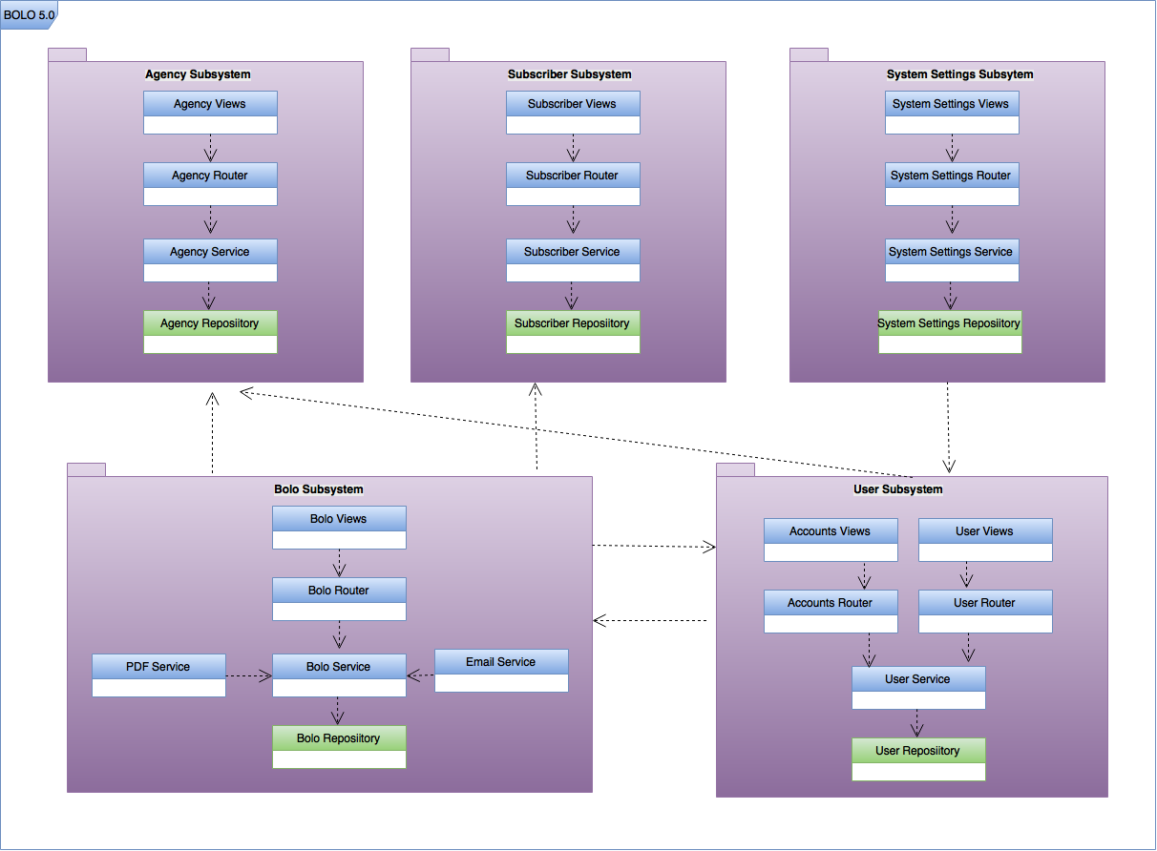 Package diagram

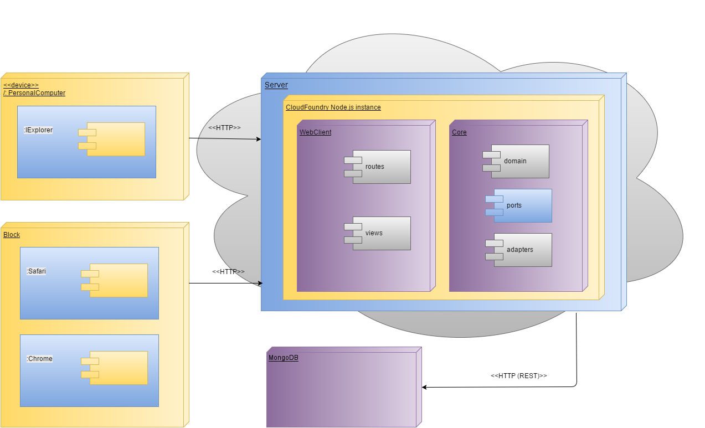

General Deployment Diagram

[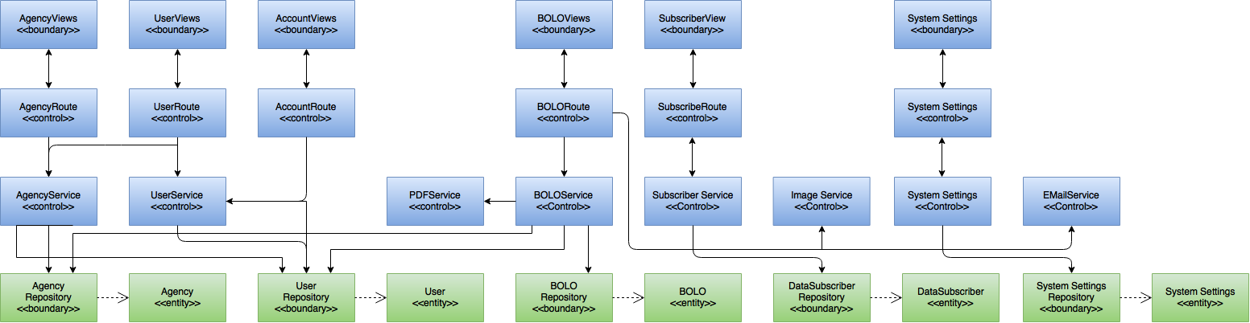](https://drive.draw.io/#G0Bw0gfTN_oxKscUVrTjFYcDNSa0U)

Minimal Class Diagram

## Design Patterns

The following design patterns were used during version 6 iteration of the BOLO Flyer Creator system:

* Observer: This is essential to maintain an organized execution of asynchronous calls in order to prevent the system from malfunctioning.
* Singleton: Only one instance of the server will be allowed to run at a time
* Repository: This abstraction is used to mediate between the domain and the persistent data storage so that if the database service was to be changed, it can be done without altering the entire code.

# System Validation

Unit test is essential to test all the layers within the application. All test cases were used to help validate user stories within the project plan section.

|  |  |
| --- | --- |
| ID | BOLO_ImageCompression_1 |
| Purpose | **Sunny-day test to check if a large .jpeg image (>1 megabyte) is compressed to less than 500kb** |
| Precondition | **The user is signed in as an administrator**  **The node app is running**  **The node app is connected to database** |
| Input | **\*.jpeg image of size 1.38 megabytes** |
| Expected Output | **“Image is of size [<500KB]”** |

|  |  |
| --- | --- |
| ID | BOLO_ImageCompression_2 |
| Purpose | **Sunny-day test to check if a small .jpeg image (<1 megabyte) is compressed to less than 500kb** |
| Precondition | **The user is signed in as an administrator**  **The node app is running**  **The node app is connected to database** |
| Input | **\*.jpeg image of size 741 kilobytes** |
| Expected Output | **“Image is of size [<500KB]”** |

|  |  |
| --- | --- |
| ID | BOLO_ImageCompression_3 |
| Purpose | **Rainy-day test to check if a small .jpeg image (<512 kilobytes) is not compressed** |
| Precondition | **The user is signed in as an administrator**  **The node app is running**  **The node app is connected to database** |
| Input | **\*.jpeg image of size 198 kilobytes** |
| Expected Output | **“Image is of size 198KB”** |

|  |  |
| --- | --- |
| ID | BOLO_CreateUser_1 |
| Purpose | **Sunny-day test to create a new officer user** |
| Precondition | **A user is signed in as an administrator**  **The node app is running**  **The node app is connected to database**  **The user does not exist on the database**  **Agency Pinecrest exists on the server** |
| Input | **Username: abc123**  **First Name: bob**  **Last Name: Test**  **Agency: Pinecrest**  **Email: abc123(@pine.gov)**  **Role: Officer**  **Badge No.: 1234**  **Section / Unit: 1234**  **Rank / Title: Test** |
| Expected Output | **“User abc123 has been registered!”** |

|  |  |
| --- | --- |
| ID | BOLO_CreateUser_2 |
| Purpose | **Sunny-day test to create a new root user** |
| Precondition | **The user is signed in as a root user**  **The node app is running**  **The node app is connected to database**  **The user does not exist on the database**  **Agency Raymond exists on the server** |
| Input | **Username: domin1**  **First Name: Dom**  **Last Name: Mar**  **Agency: Raymond**  **Email: abc-123(@gmail.com)**  **Role: Root**  **Badge No.: 1234**  **Section / Unit: 1234**  **Rank / Title: Test** |
| Expected Output | **“User domin1 has been registered!”** |

|  |  |
| --- | --- |
| ID | BOLO_CreateUser_3 |
| Purpose | **Rainy-day test to check if the system will catch a validation error of an incorrect email** |
| Precondition | **The user is signed in as a root user**  **The node app is running**  **The node app is connected to database**  **The user does not exist on the database**  **Agency Raymond exists on the server** |
| Input | **Username: do@#m**  **First Name: Dom**  **Last Name: Mar**  **Agency: Raymond**  **Domain: ab^c-123(@gmail.com)**  **Role: Supervisor**  **Badge No.: 1234**  **Section / Unit: 1234**  **Rank / Title: Test** |
| Expected Output | **“Email is not Valid”** |

|  |  |
| --- | --- |
| ID | BOLO_DeleteUser_1 |
| Purpose | **Sunny-day test to check if an existing officer on the database is removed after password conformation** |
| Precondition | **The user is signed in as a root user**  **The node app is running**  **The node app is connected to database**  **The user ‘deleteMe’ exists on the database** |
| Input | **Select ‘Delete User’ on ‘deleteMe’ user details page**  **Enter correct password** |
| Expected Output | **“User ‘deleteMe’ has been deleted”** |

|  |  |
| --- | --- |
| ID | BOLO_DeleteUser_2 |
| Purpose | **Rainy-day test to check if an existing officer on the database fails to be removed after password is entered incorrectly** |
| Precondition | **The user is signed in as a root user**  **The node app is running**  **The node app is connected to database**  **The user ‘deleteMe’ exists on the database** |
| Input | **Select ‘Delete User’ on ‘deleteMe’ user details page**  **Enter incorrect user password** |
| Expected Output | **“Password was incorrect. Please try again”** |

|  |  |
| --- | --- |
| ID | BOLO_CreateCategory_1 |
| Purpose | **Sunny-day test to check if the system will save a new category correctly** |
| Precondition | **The user is signed in as a root user**  **The node app is running**  **The node app is connected to database**  **The category Car already exists on the database** |
| Input | **Enter A Name For The New BOLO Category: Tester**  **Enter Fields {abc, qwe, asd, zxc, xyz}** |
| Expected Output | **“Category Tester has been created”** |

|  |  |
| --- | --- |
| ID | BOLO_CreateCategory_1 |
| Purpose | **Rainy-day test to check if the system will not save a new category with the same name** |
| Precondition | **The user is signed in as a root user**  **The node app is running**  **The node app is connected to database**  **The category Car already exists on the database** |
| Input | **Enter A Name For The New BOLO Category: Car**  **Enter Fields {abc, qwe, asd, zxc, xyz}** |
| Expected Output | **“Category Car already exists on the database”** |

# Glossary

**Administrator**: A police agent that operates from a desk coordinating and overviewing tasks.

**Agency**: A district-based police department.

**BOLO:** A “Be On the Look Out” flyer that contains information about a specific crime.

**Data Subscriber: A u**ser that is notified when a BOLO has been updated

**Officer**: A police agent assigned to a crime scene.

**Supervisor:** A police field operator in charge of multiple cases.

**Root Administrator**: An officer that has universal access to the system. They can delete users, agencies, and bolos. They can also edit selected webpages on the website.

# Appendix

## Appendix A – UML Diagrams

### Static UML Diagrams

#### Sprint 1

(08/27/2016 - 09/09/2016)

**User Story #1177** View All Pictures on BOLO Details View

* Figure sp1-1



**User Story #1187** Generate Watermark on BOLOs

* Figure sp1-2



**User Story #1179** Batch Upload of New Users

* Figure sp1-3



**User Story #1186** New User Button

* Figure sp1-4



#### Sprint 2

(09/10/2016 - 09/23/2016)

**User Story #1189** Agency Specific BOLO

* Figure sp2-1



**User Story #1190** Agency Specific View

* Figure sp2-2



**User Story 1182** Edit About Us Page

* Figure sp2-3

**User Story 1183** Edit Login Page

* Figure sp2-4



**User Story 1184** Edit User Guide Page

* Figure sp2-5



#### Sprint 3

(09/24/2016 – 10/07/2016)

**User Story #1194** BOLO Category Template Creation

* Figure sp3-1



**User Story #1191** Email PDF Privacy

* Figure sp3-2



**User Story #1196** Template Rendering

* Figure sp3-3



**User Story #1188** Convert Database to MongoDB

* Figure sp3-4

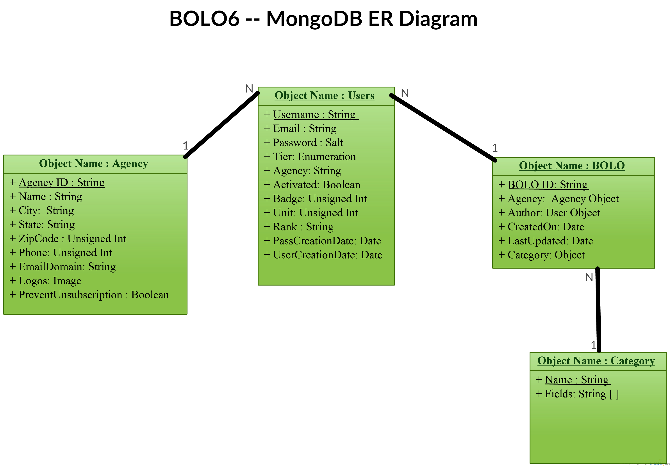

#### Sprint 4

(10/08/2016 – 10/21/2016)

**User Story #1198** Adjust BOLO View

* Figure sp4-1



**User Story #1200** Adjust Email PDF Privacy for MongoDB

* Figure sp4-2



**User Story #1199** Adjust PDF Rendering for MongoDB

* Figure sp4-3



**User Story #1195** CSV Upload

* Figure sp4-4



**User Story #700** Delete Agency

* Figure sp4-5



**User Story #1192** Delete User

* Figure sp4-6



**User Story #1197** Email Confirmation

* Figure sp4-7



**User Story #1188** Convert Database to MongoDB

* Figure sp4-9

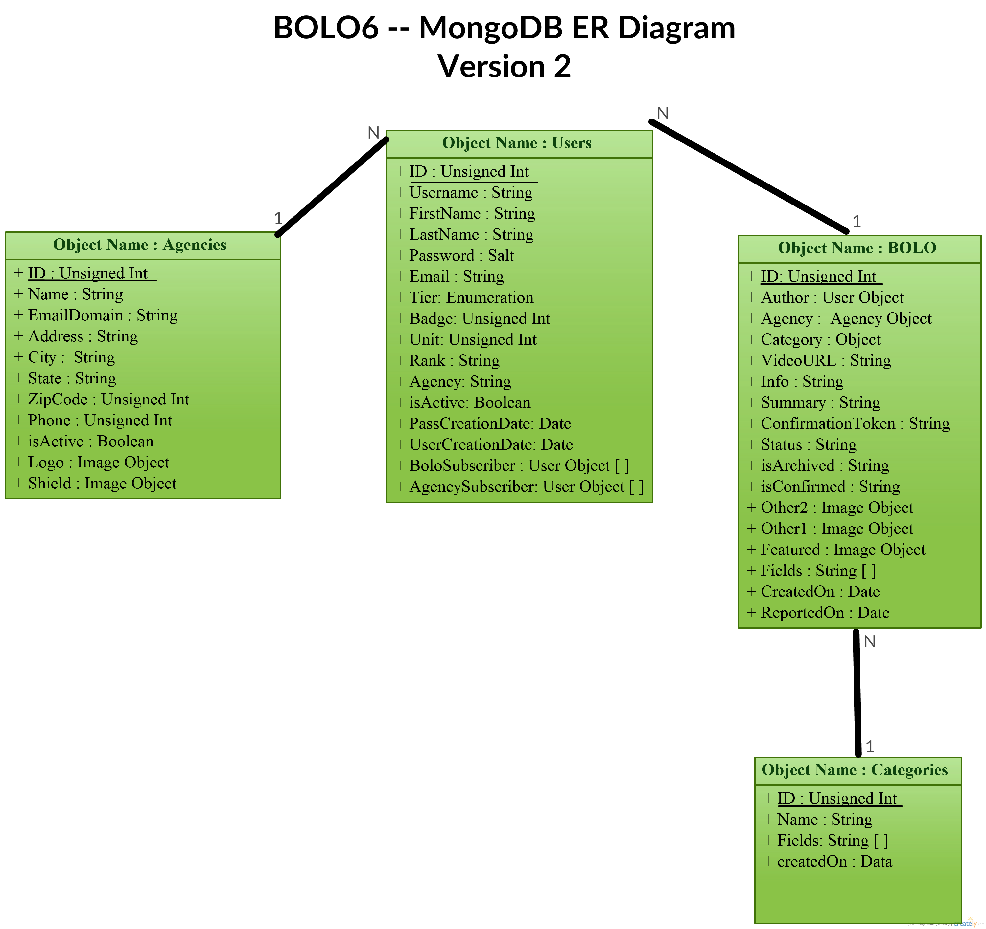

#### Sprint 5

(10/22/2016 – 11/04/2016)

**User Story #1193** Image Compression

* Figure sp5-1



**User Story #1204** Data Analysis

* Figure sp5-2



**User Story #1180** Set Password

* Figure sp5-3



**User Story #1206** New User Notification

* Figure sp5-4



#### Sprint 6

(11/05/2016 – 11/11/2016)

**User Story #1205** Password Verification

* Figure sp6-1



**User Story #1201** BOLOData Subscriber

* Figure sp6-2

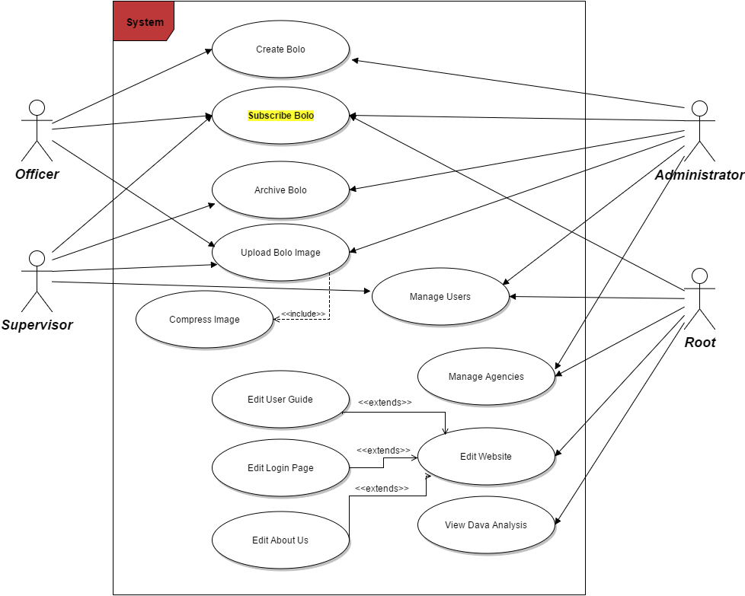

### Dynamic UML Diagrams

#### Sprint 1

(08/27/2016 - 09/09/2016)

**User Story #1177** View All Pictures on BOLO Details View

* Figure sp1-1



**User Story #1187** Generate Watermark on BOLOs

* Figure sp1-2



**User Story #1179** Batch Upload of New Users

* Figure sp1-3



**User Story #1186** New User Button

* No diagram for this user story

#### Sprint 2

(09/10/2016 - 09/23/2016)

**User Story #1189** Agency Specific BOLO

* Figure sp2-1



**User Story #1190** Agency Specific View

* Figure sp2-2



**User Story 1182** Edit About Us Page

* Figure sp2-3

**User Story 1183** Edit Login Page

* Figure sp2-4

**User Story 1184** Edit User Guide Page

* Figure sp2-5



#### Sprint 3

(09/24/2016 – 10/07/2016)

**User Story #1194** BOLO Category Template Creation

* Figure sp3-1



**User Story #1191** Email PDF Privacy

* Figure sp3-2



**User Story #1196** Template Rendering

* Figure sp3-3



#### Sprint 4

(10/08/2016 – 10/21/2016)

**User Story #1198** Adjust BOLO View

* Figure sp4-1



**User Story #1200** Adjust Email PDF Privacy for MongoDB

* Figure sp4-2



**User Story #1192** Delete User (performed by admin user)

* Figure sp4-3

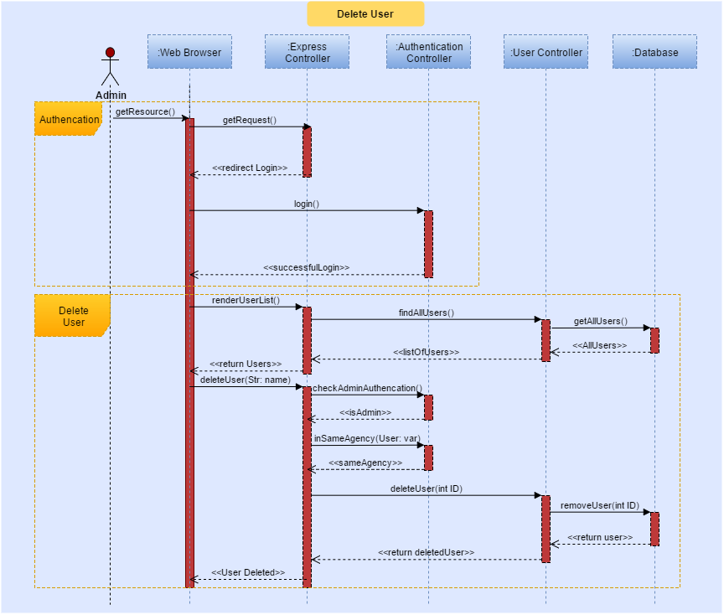

**User Story #1192** Delete User (performed by root user)

* Figure sp4-4

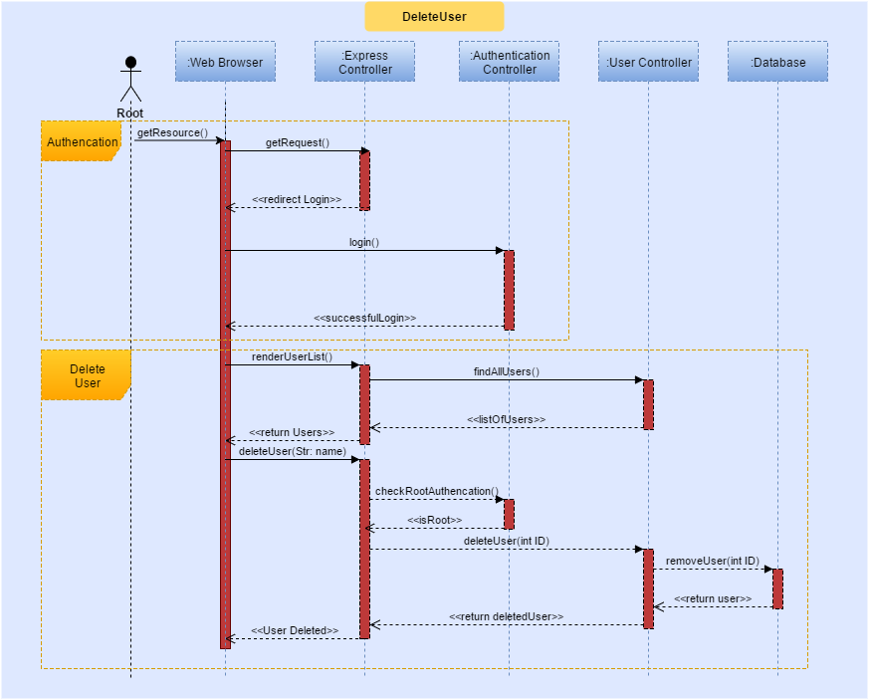

**User Story #700** Delete Agency

* Figure sp4-5

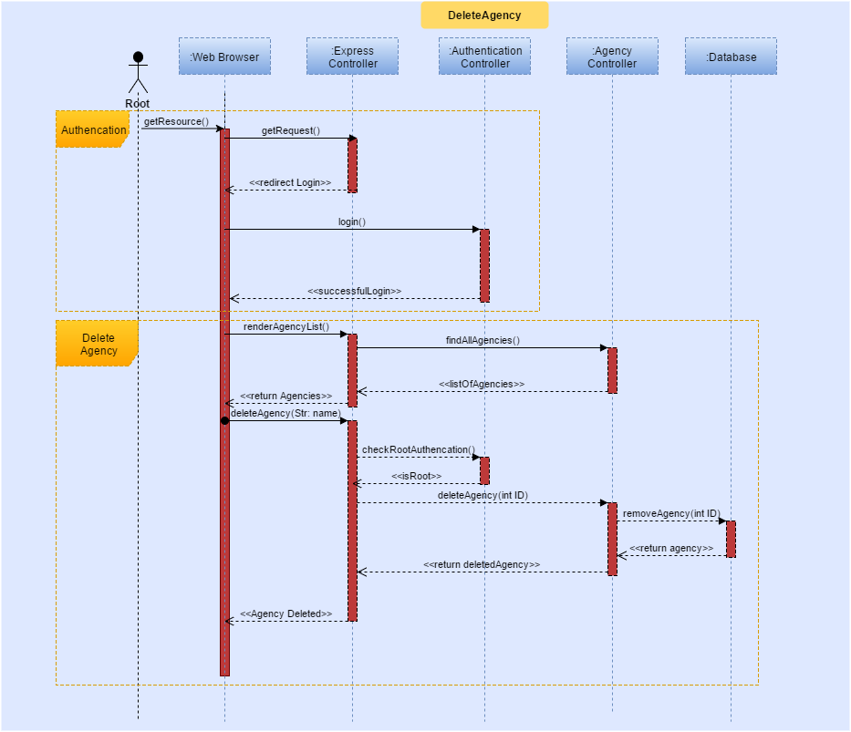

**User Story #1197** Email Confirmation

* Figure sp4-6

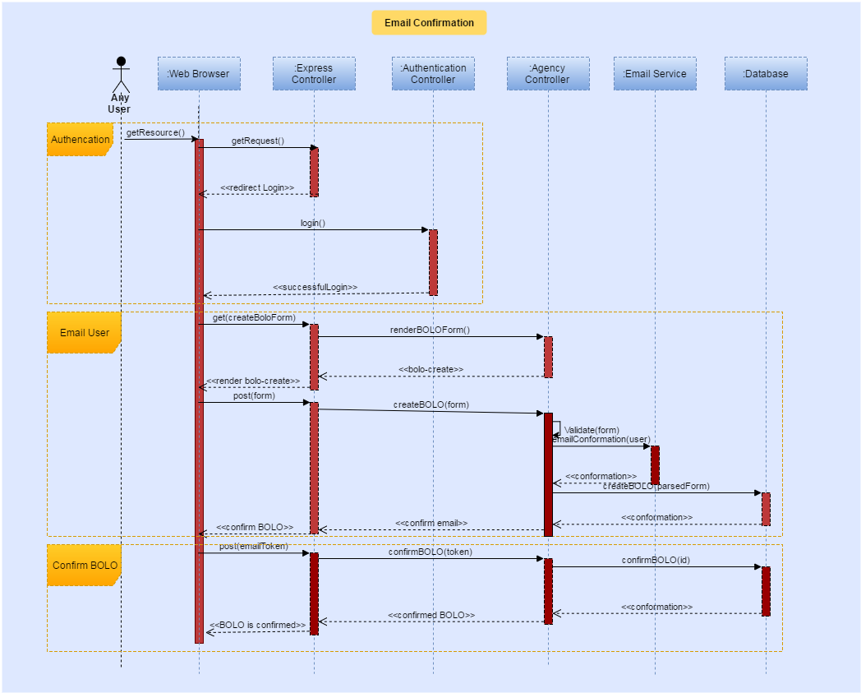

**User Story #1199** Adjust PDF Rendering for MongoDB

* Figure sp4-7



**User Story #1195** CSV Upload

* Figure sp4-8



#### Sprint 5

(10/22/2016 – 11/04/2016)

**User Story #1204** Data Analysis

* Figure sp5-1



**User Story #1193** Image Compression

* Figure sp5-2

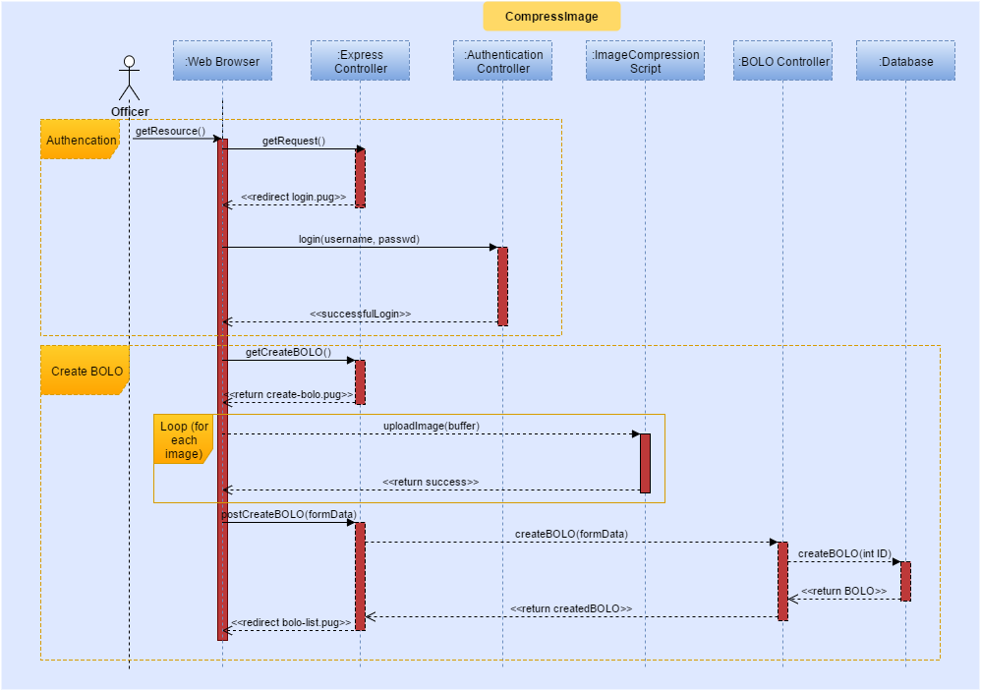

**User Story #1180** Set Password

* Figure sp5-3



**User Story #1202** BOLO Image Resizing

* Figure sp5-4



**User Story #1202** New User Notification

* Figure sp5-5



#### Sprint 6

(11/05/2016 – 11/11/2016)

**User Story #1201** BOLOData Subscriber

* Figure sp6-1

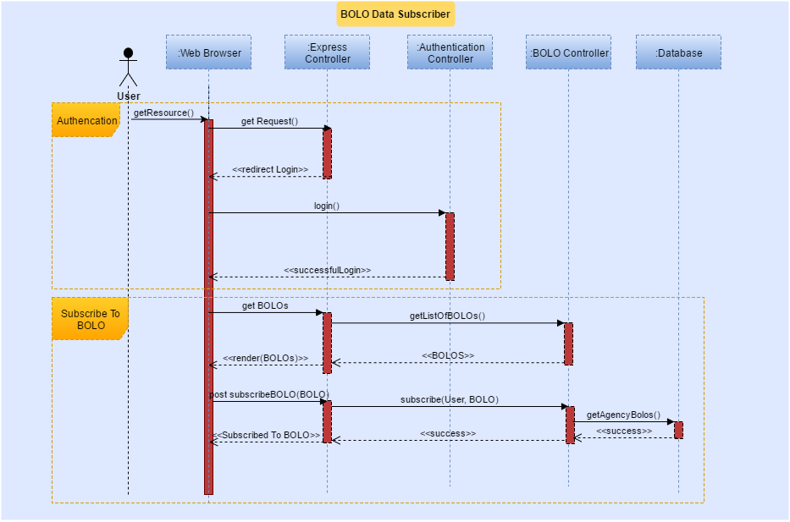

**User Story #1205** Password Verification

* Figure sp6-2



## Appendix B – User Interface Design

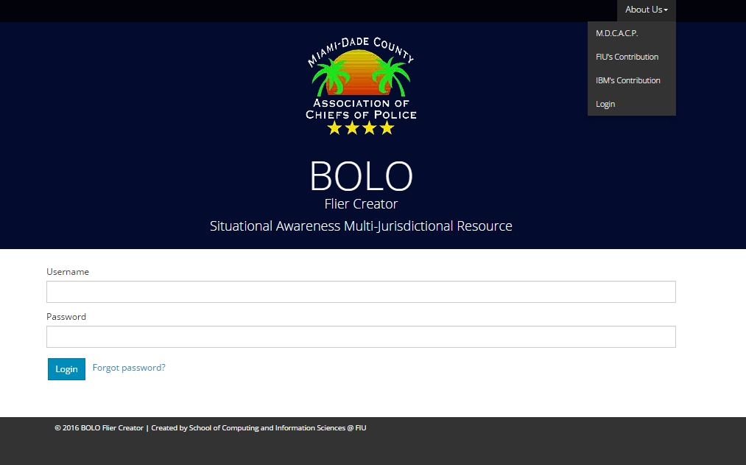

Figure UI01 – About us

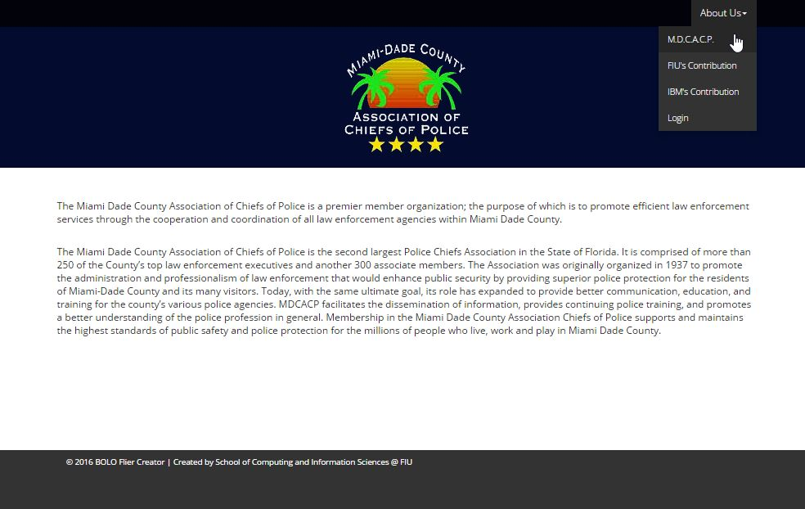

Figure UI02 – About us Miami Dade Association of Chiefs of Police



Figure UI03 – About us FIU

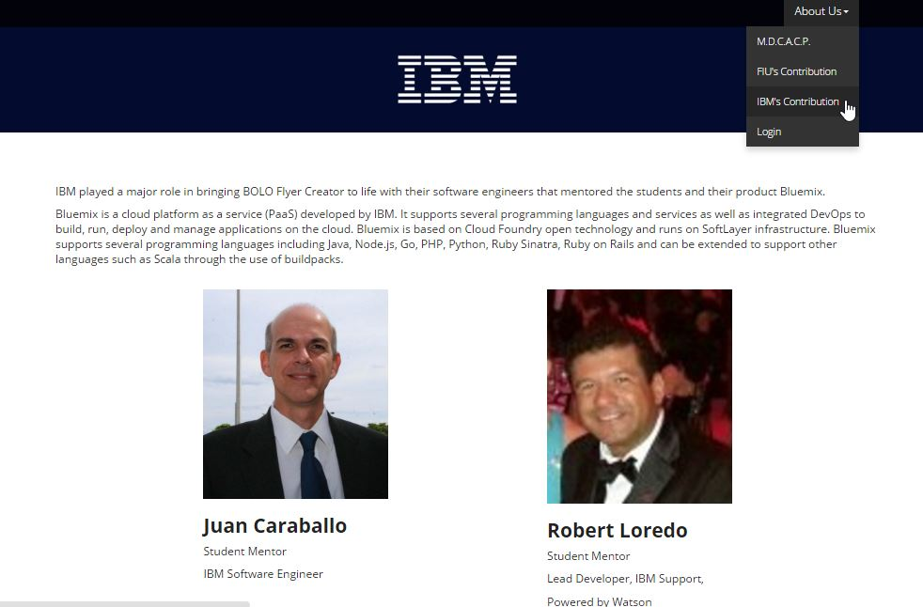

Figure UI04 – About us IBM

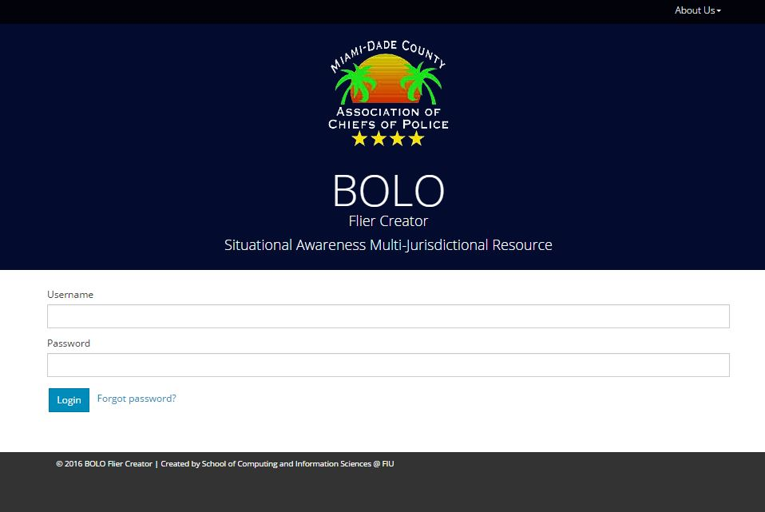

Figure UI05 – Login

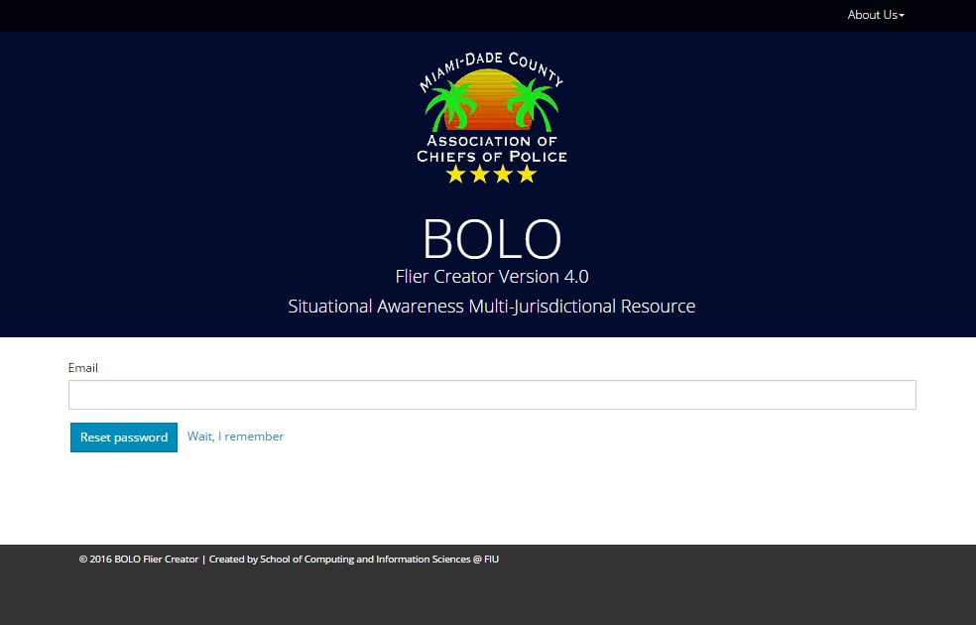

Figure UI06 – Forgot Password

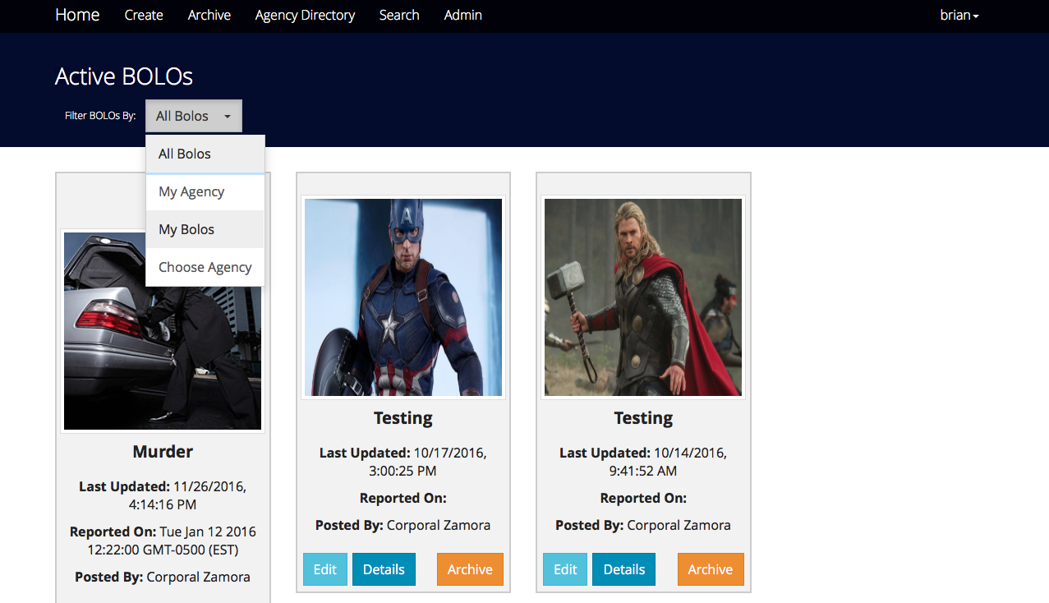

Figure UI07 – Filter Bolos

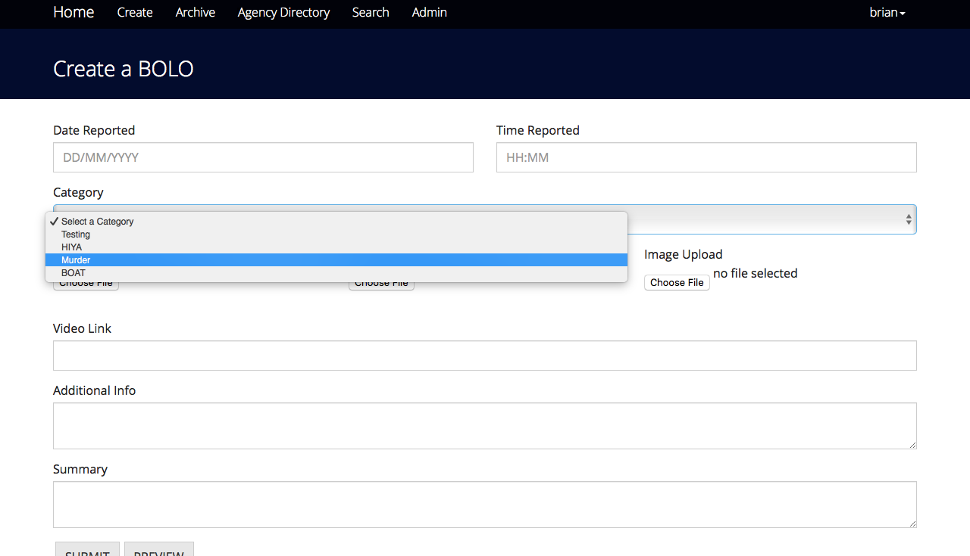

Figure UI09 – Create Bolo Form

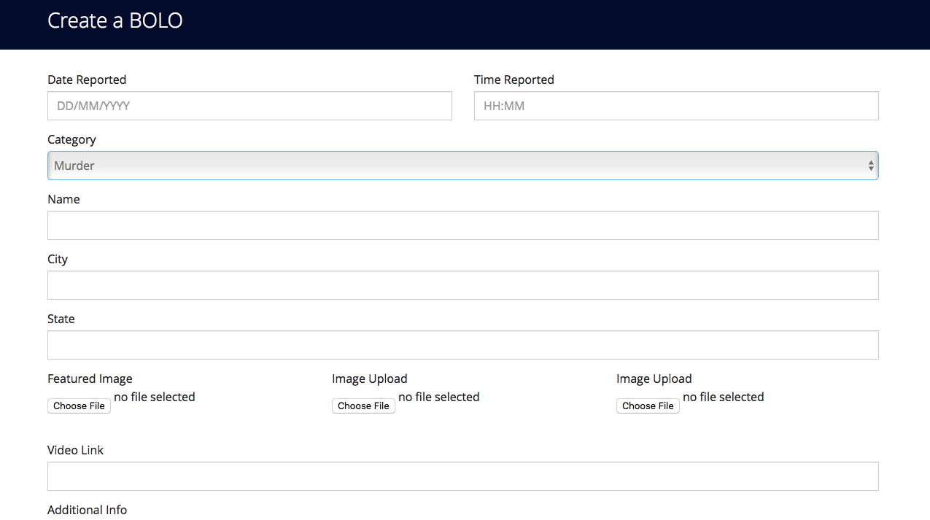

Figure UI10 – BOLO Category Rendering

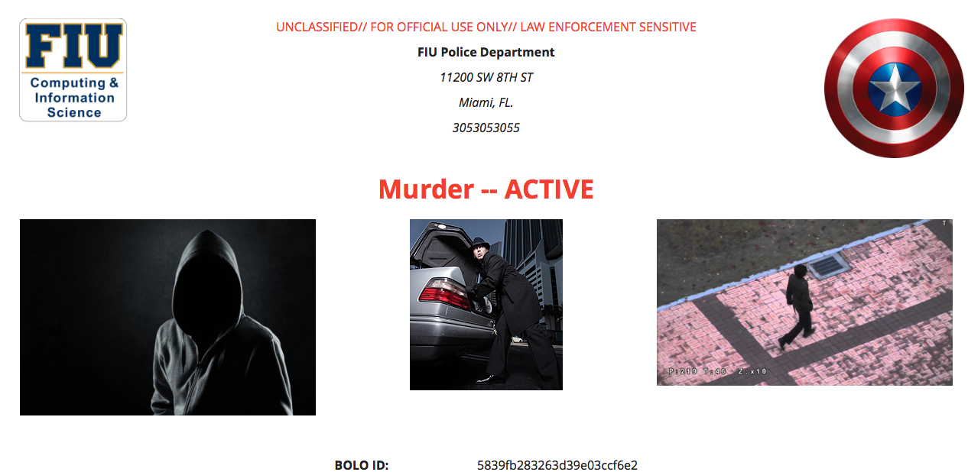

Figure UI11 – BOLO Details View

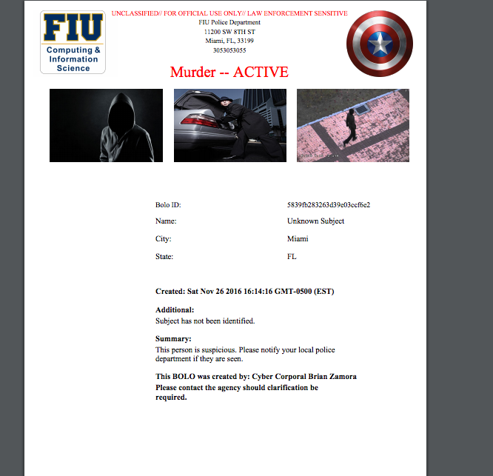

Figure UI12 – BOLO PDF Rendering

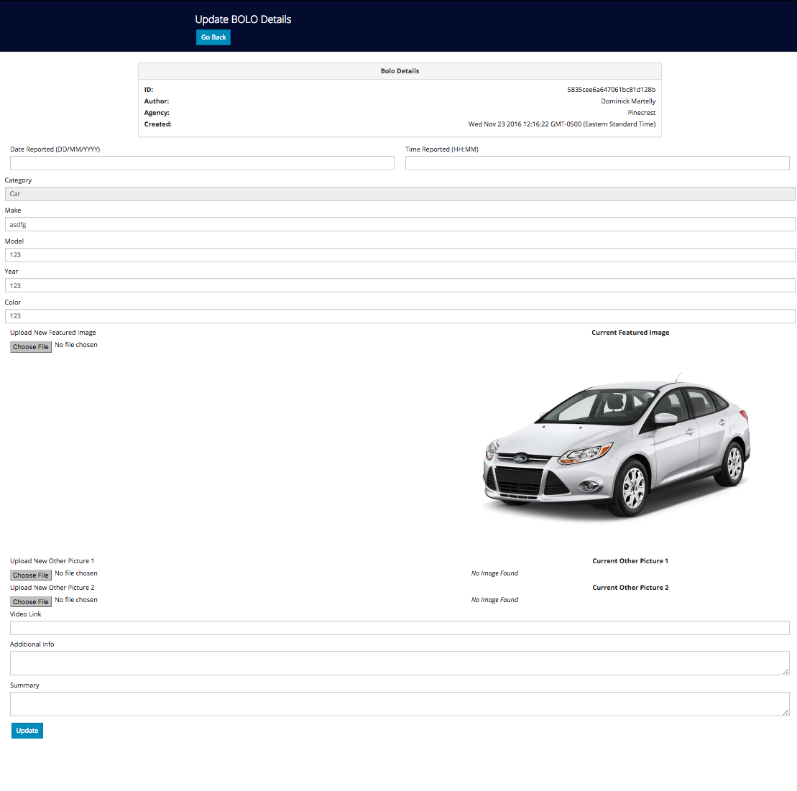

Figure UI13 – Edit Bolo

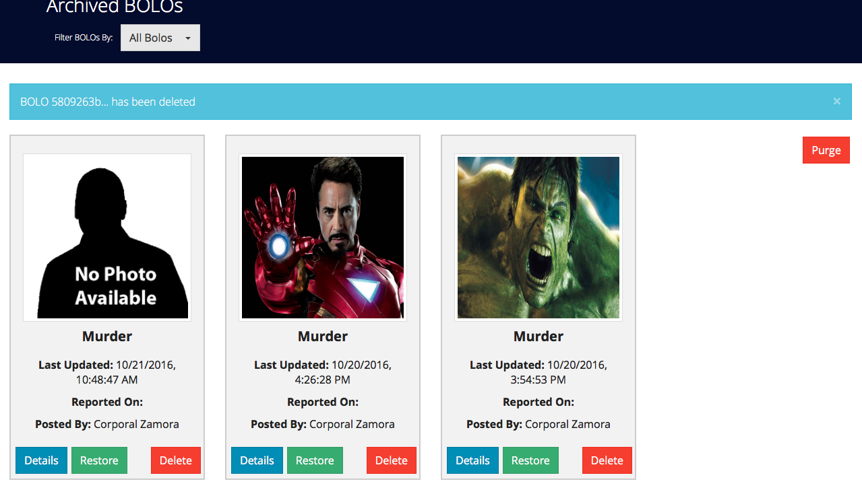

Figure UI14 – Archived Bolos

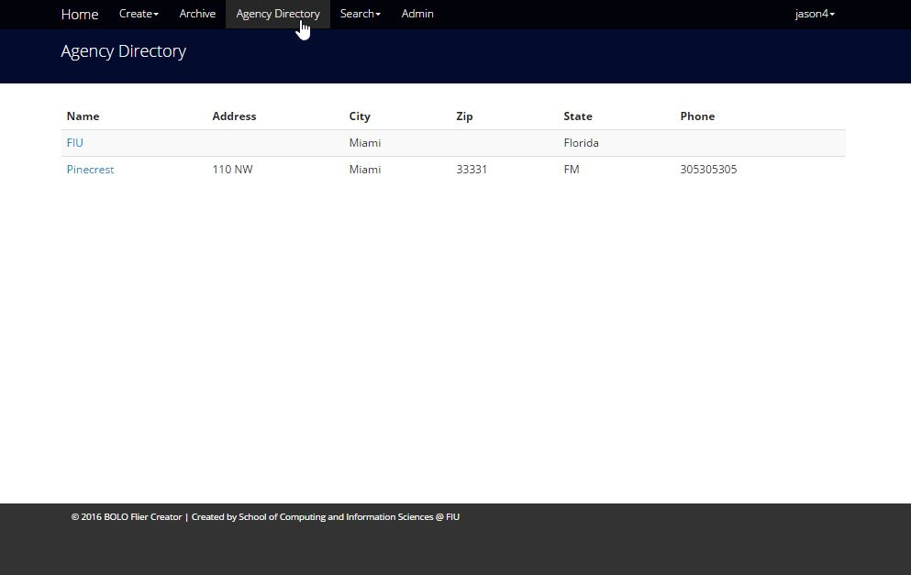

Figure UI15 – Agency Directory

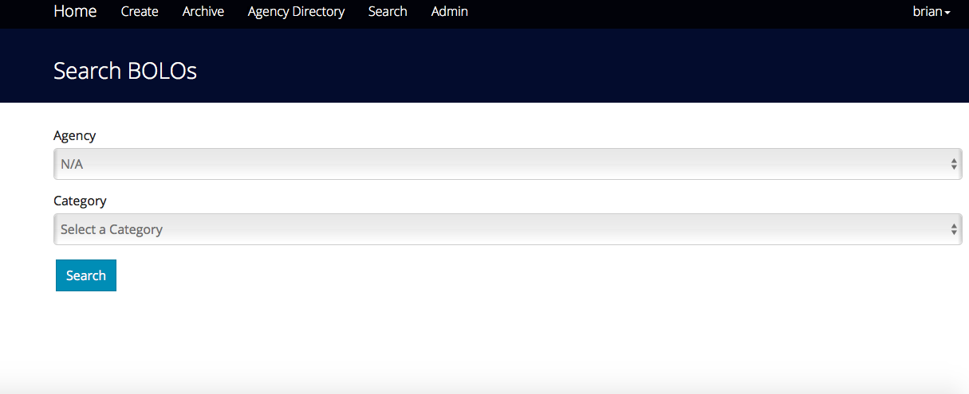

Figure UI16 – Search Bolo

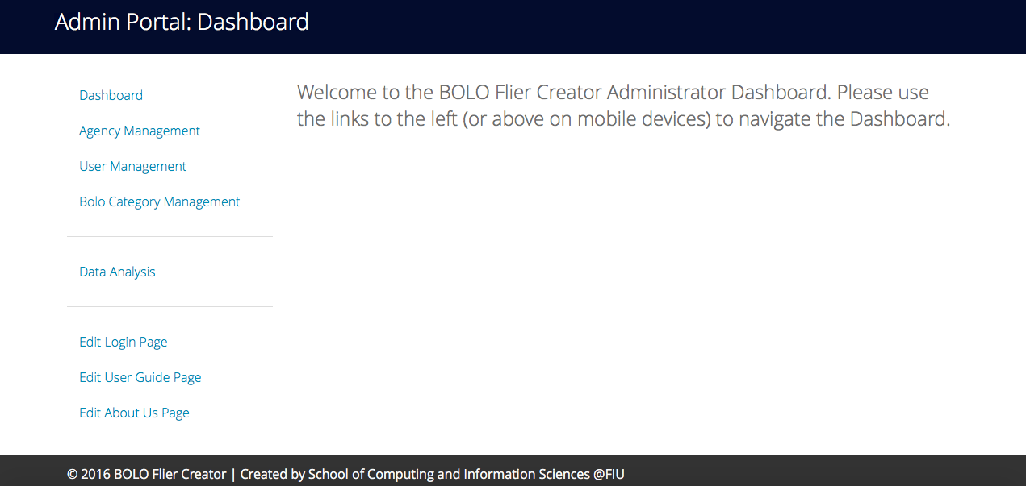

Figure UI17 – Admin Dashboard

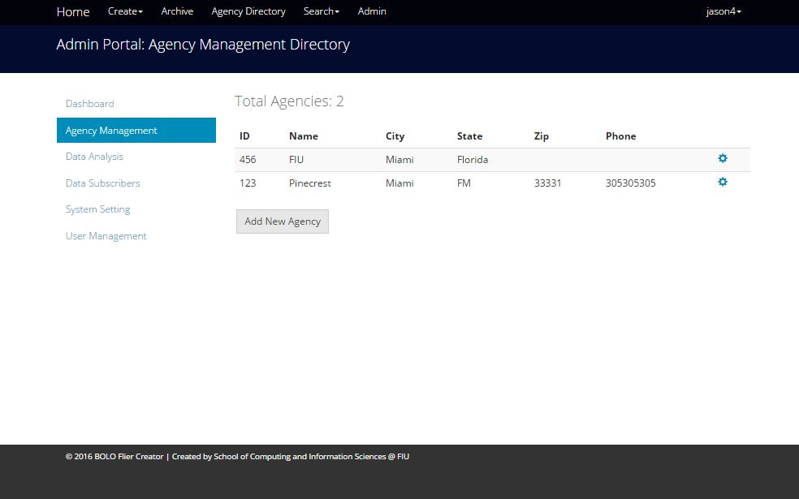

Figure UI18 – Agency Management

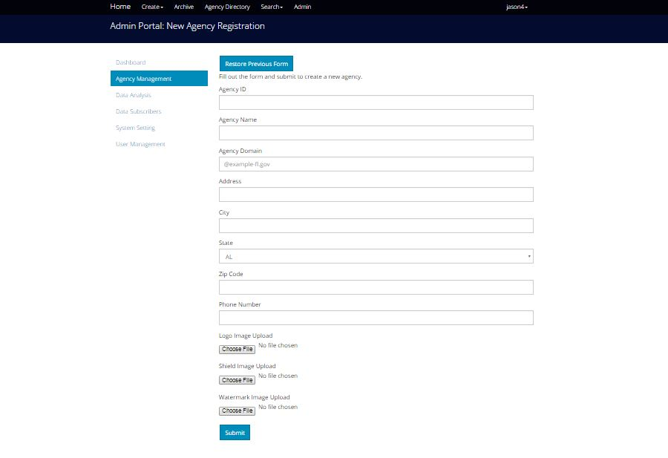

Figure UI19 – Create New Agency

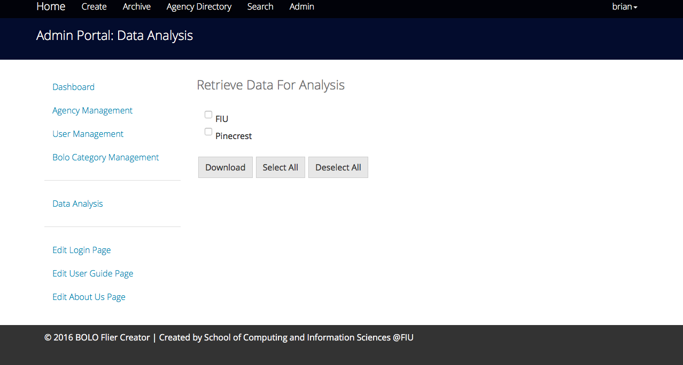

Figure UI20 – Data Analysis

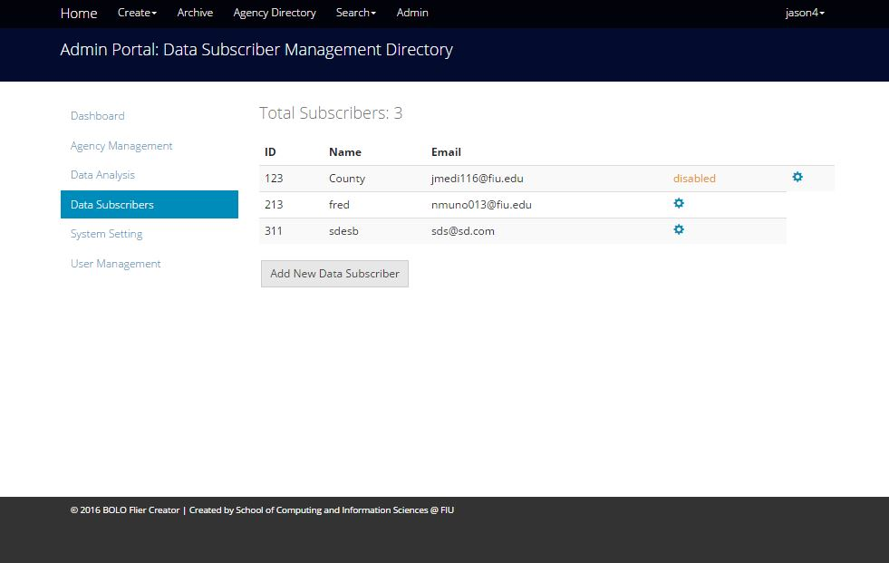

Figure UI21 – Data Subscribers

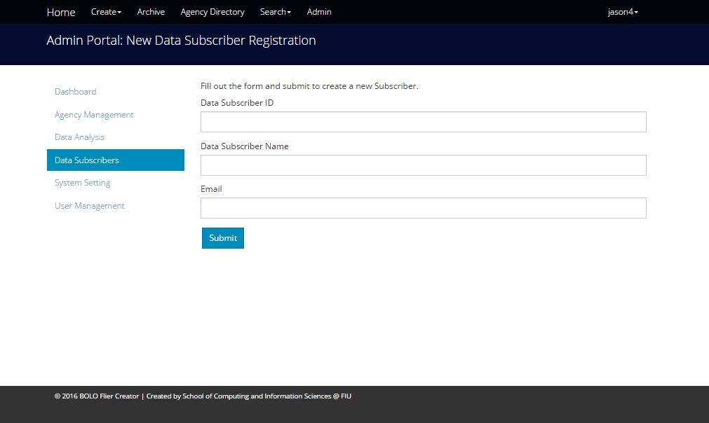

Figure UI22 – Create Data Subscriber

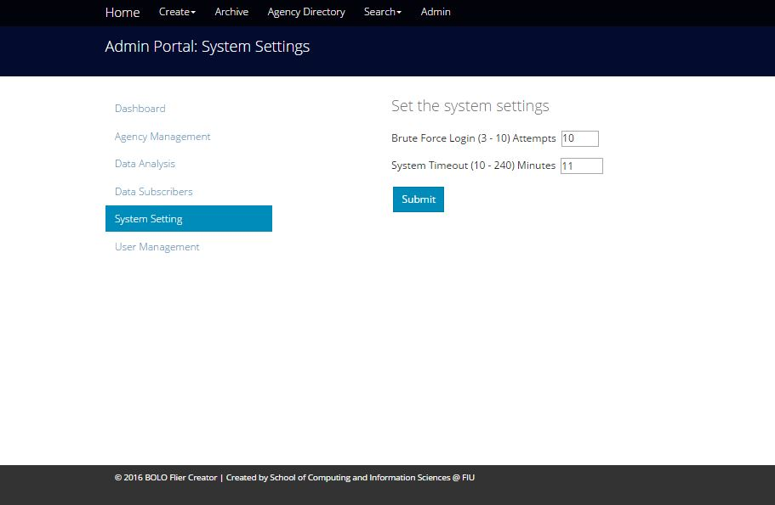

Figure UI23 – System Settings

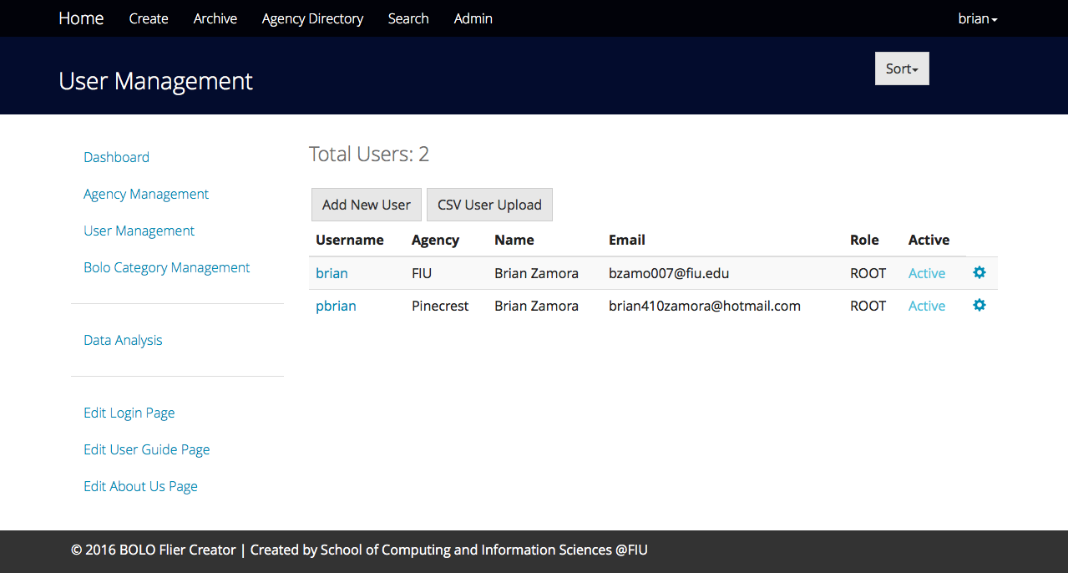

Figure UI24 – User Management

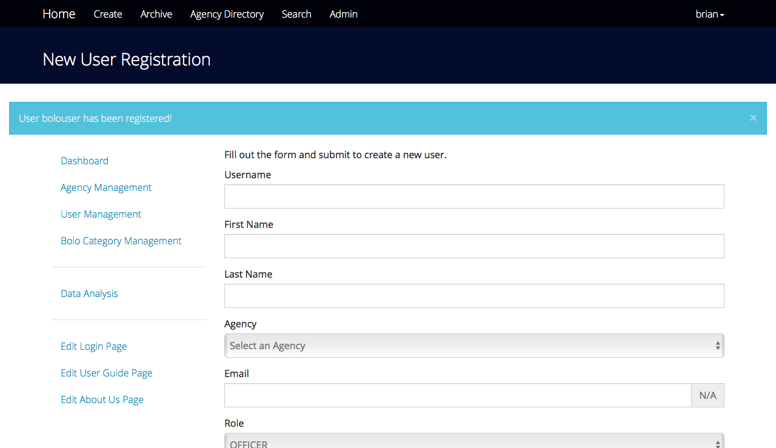

Figure UI25 – Create New User

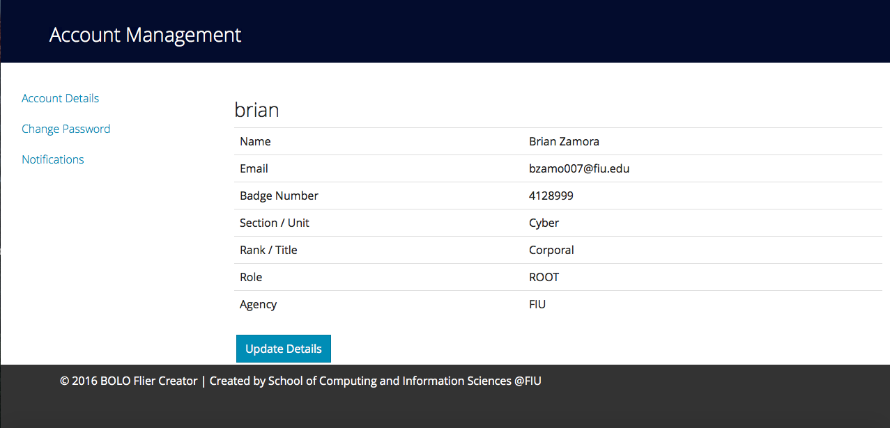

Figure UI26 – Account Details

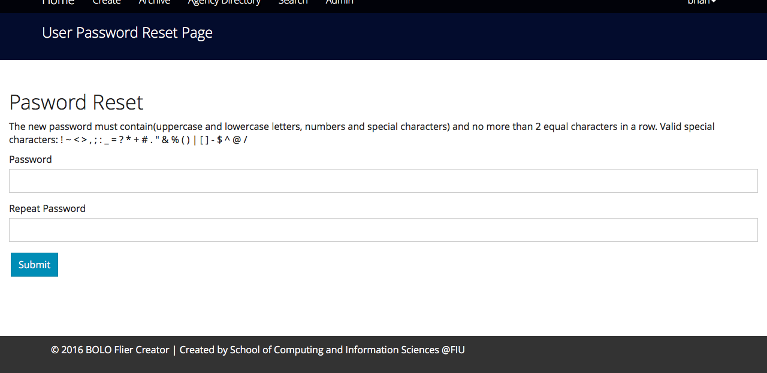

Figure UI27 – Change Password

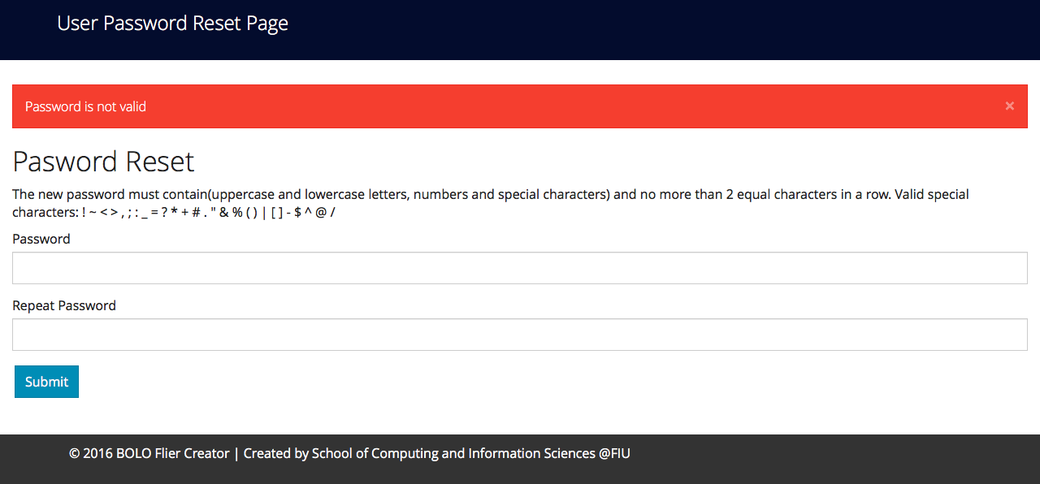

Figure UI28 – Password Verification

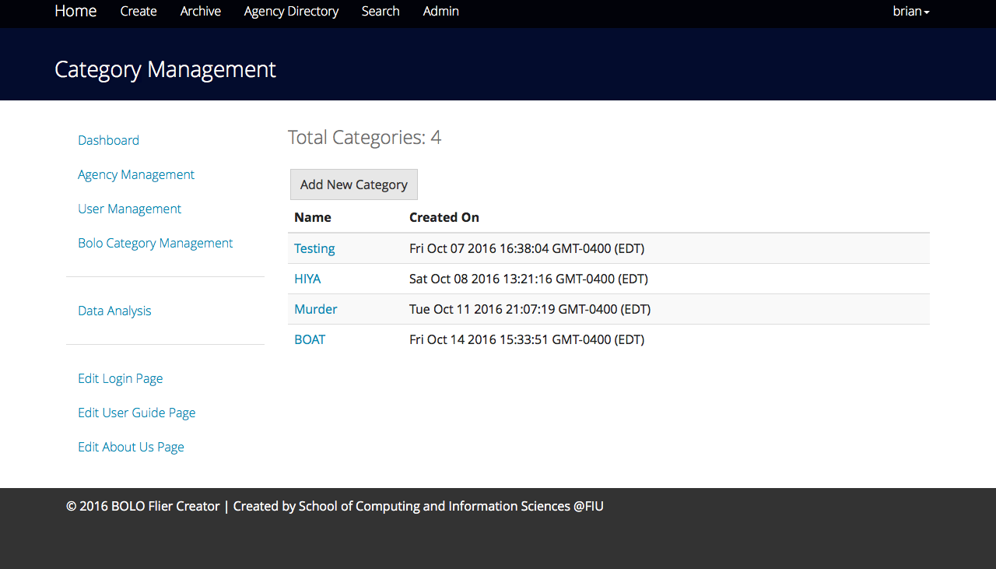

Figure UI29 – Category Management

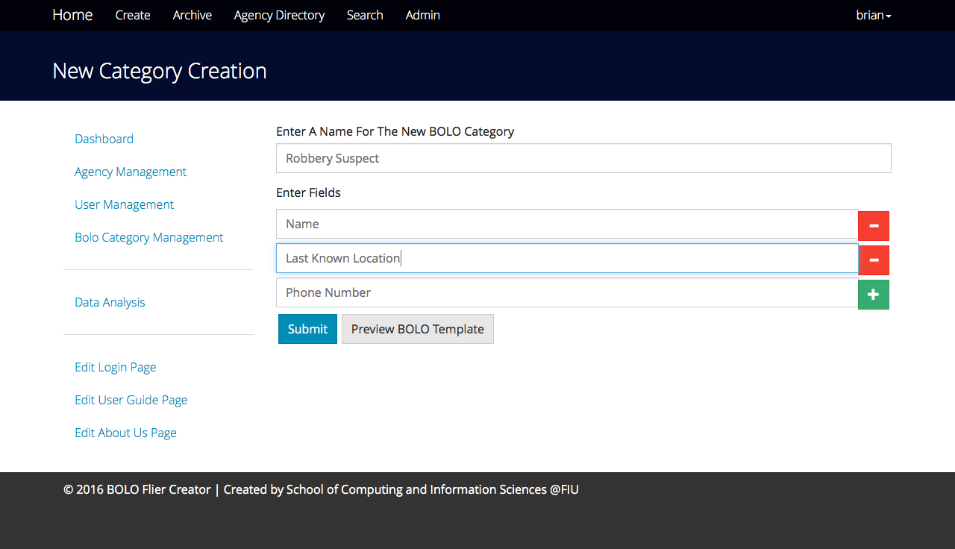

Figure UI30 – Category Creation

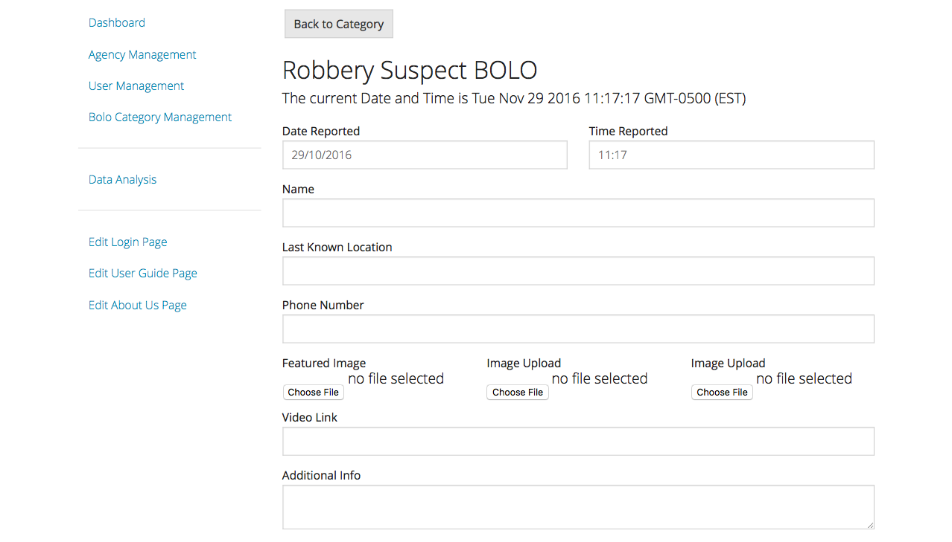

Figure UI31 – Category Preview

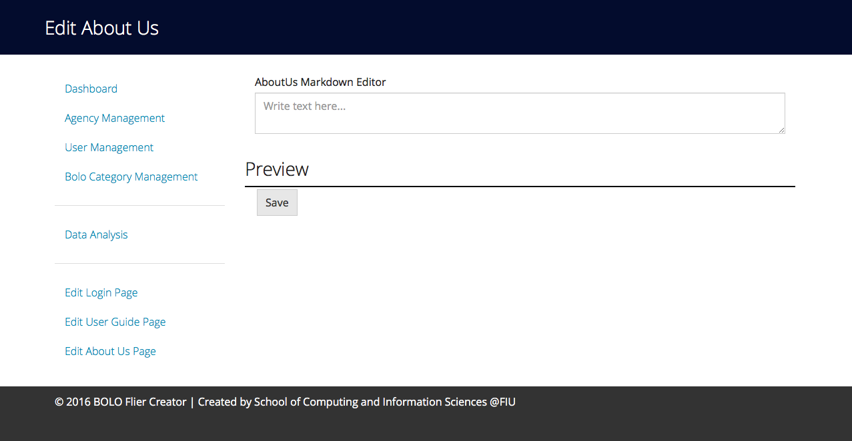

Figure UI32 – Edit About Us

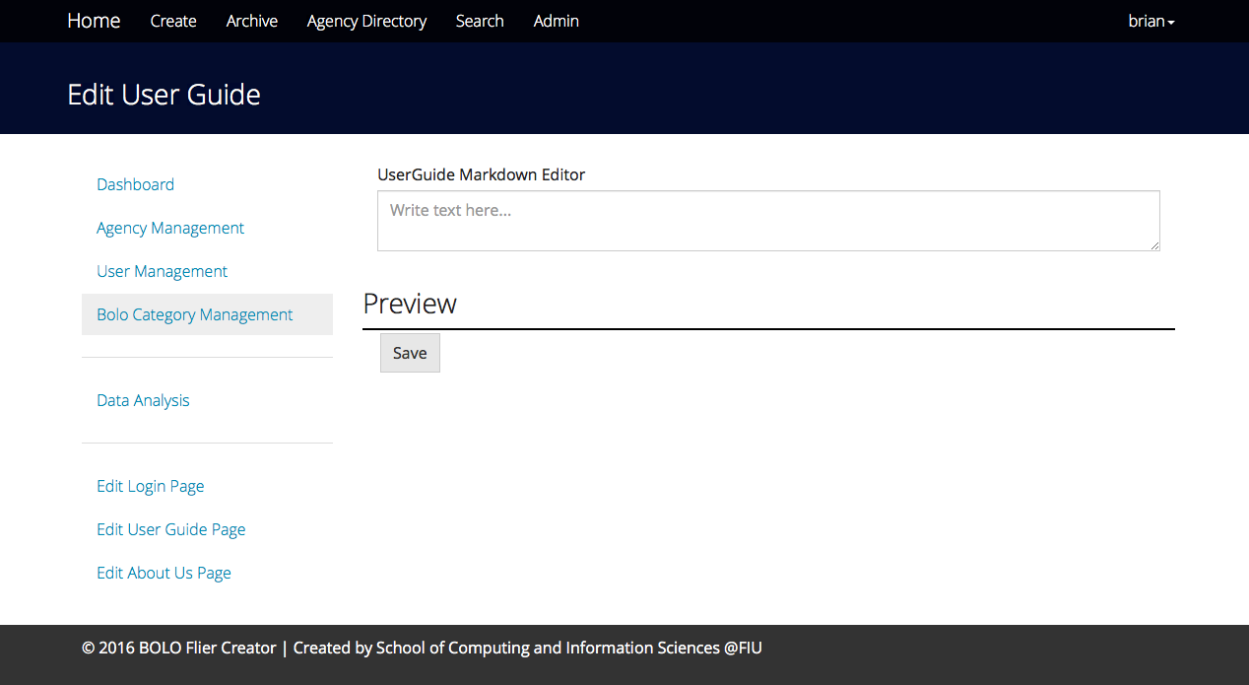

Figure UI33 – Edit User Guide

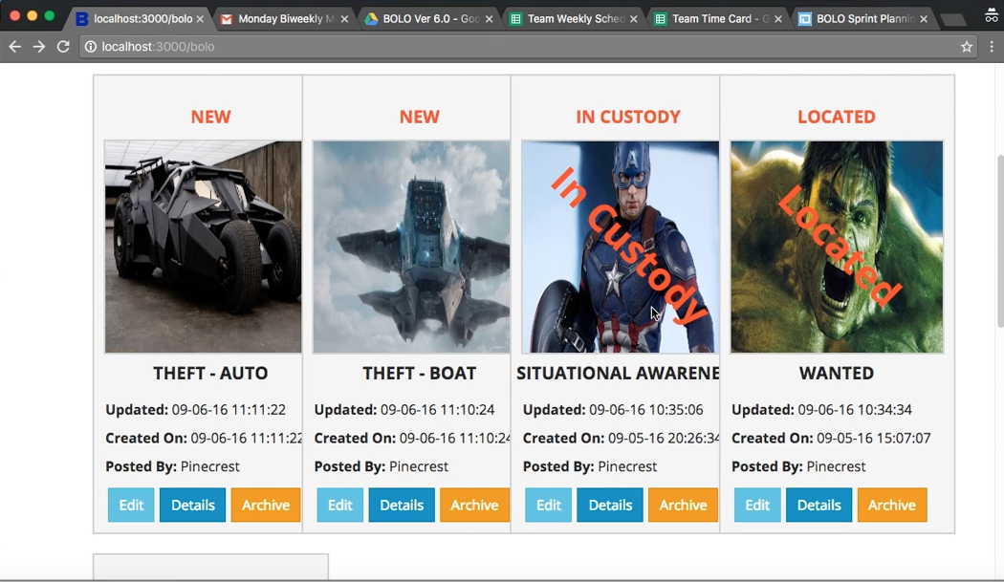

Figure UI34 – BOLO Watermark

## Appendix C – Sprint Reports

**Sprint Review**

**Sprint 1 Review**

August 29 - September 9

Date: September 9th, 2016

Attendees: Dominick Martelly, Brian Zamora, Jason Cohen, Frank Jagger

Start time: 2:00pm

End time: 2:30pm

After a show and tell presentation, the implementation of the following user stories were accepted by the product owners:

* #1777_ViewAllPictures
* #1187_AddWatermark
* #1186_AddNewUserButton
* #1179_BatchUploadUsers

The following ones were rejected and moved back to the product backlog to be assigned to a future sprint at a future Spring Planning meeting.

* #1179_BatchUploadUsers
  + - The product owner wanted a different design for the batch upload
* #1182_EditAboutUs
  + - We were not able to get to this user story during this sprint
* #1183_LoginHomePage
  + - We were not able to get to this user story during this sprint
* #1184_EditUserGuide
  + - We were not able to get to this user story during this sprint
* #1189_AgencySpecificBOLO
  + - We were not able to get to this user story during this sprint
* #1180_SetPassword
  + - This user story will be implemented at a later time, the product owner has expressed that it is not a priority for this iteration.

**Sprint 2 Review**

September 10 - September 23

Date: September 23rd, 2016

Attendees: Dominick Martelly, Brian Zamora, Jason Cohen, Frank Jagger

Start time: 2:00pm

End time: 2:30pm

After a show and tell presentation, the implementation of the following user stories were accepted by the product owners:

* #1179_BatchUploadUsers
* #1182_EditAboutUs
* #1183_LoginHomePage
* #1184_EditUserGuide
* #1189_AgencySpecificBOLO
* #1180_SetPassword
* #1190_AgencySpecificView

The following ones were rejected and moved back to the product backlog to be assigned to a future sprint at a future Spring Planning meeting.

* #1180_SetPassword
  + - This user story will be implemented at a later time, the product owner has expressed that it is not a priority for this iteration.

**Sprint 3 Review**

September 24 - October 7

Date: October 7th, 2016

Attendees: Dominick Martelly, Brian Zamora, Jason Cohen

Start time: 1:50pm

End time: 2:10pm

After a show and tell presentation, the implementation of the following user stories were accepted by the product owners:

* #1191_EmailPDFPrivacy
* #1194_ BOLOCategoryCreation
* #1196_BOLOCategoryRendering

The following ones were rejected and moved back to the product backlog to be assigned to a future sprint at a future Spring Planning meeting.

* #1198_AdjustBOLOViewForMongoDB
  + The product owner wants the view of bolo details to use more of the user space for pictures and details of the bolo
* #1197_Email Confirmation
  + - The email confirmation system is going to be changed, because of an upcoming change in the database. As a result, this user story will be moved to sprint 4

**Sprint 4 Review**

October 7 - September 21

Date: September 21st, 2016

Attendees: Dominick Martelly, Brian Zamora, Jason Cohen

Start time: 1:50pm

End time: 2:10pm

After a show and tell presentation, the implementation of the following user stories were accepted by the product owners:

* #1188_ChangeToMongoDB
* #1192_DeleteUser
* #700_DeleteAgency
* #1195_AdjustCSVUploadingMongoDB
* #1199_PDFRenderingMongoDB
* #1197_Email Confirmation
* #1200_PDF Email Privacy
* #1198_AdjustBOLOViewMongoDB

The following ones were rejected and moved back to the product backlog to be assigned to a future sprint at a future Spring Planning meeting.

* #1193_BOLOImage Compression
  + - The product owner wanted us to look for a new image compression tool or algorithm so that generated PDFs would be below 5MB.
* #1202_BOLOImageResizing
  + - The product owner wanted images to be as big as they possibly can be based on how many images are going to be displayed

**Sprint 5 Review**

October 22 - November 4

Date: November 4th, 2016

Attendees: Dominick Martelly, Brian Zamora, Jason Cohen, Frank Jagger

Start time: 1:35pm

End time: 1:45pm

After a show and tell presentation, the implementation of the following user stories were accepted by the product owners:

* #1202_BOLOImageResizing
* #1193_BOLOImageCompression
* #1180_SetPassword
* #1206_NewUserNotification
* #1180_SetPassword

The following ones were rejected and moved back to the product backlog to be assigned to a future sprint at a future Spring Planning meeting.

* No Implementations were rejected

**Sprint 6 Review**

November 5 - November 11

Date: November 11th, 2016

Attendees: Dominick Martelly, Brian Zamora, Frank Jagger

Start time: 1:35pm

End time: 1:45pm

After a show and tell presentation, the implementation of the following user stories were accepted by the product owners:

* #1201_BOLODataSubscriber
* #1205_BOLOPasswordVerification

The following ones were rejected and moved back to the product backlog to be assigned to a future sprint at a future Spring Planning meeting.

* No Implementations were rejected

**Sprint Retrospective**

**Sprint 1 Retrospective**

August 29 - September 9

Date: September 9th, 2016

Attendees: Dominick Martelly, Joseph Casal, Brian Zamora

Start time: 3:00pm

End time: 3:30pm

What went wrong?

* Did we do a good job estimating our team's velocity?
  + No
* Did we do a good job estimating the points (time required) for each user story?
  + Yes, the points reflects the amount of work needed to be done for each user story
* Did each team member work as scheduled?
  + Yes, but the schedule needs to be filled out more

What went right?

* Implementing at least one of the assigned user case for that sprint
* Good communication with the product owner

How to address the issues in the next sprint?

* How to improve the process?
  + Everyone comes to the meeting on time
  + Increase the amount of work hours for each sprint
* How to improve the product?
  + By making the GUI more user friendly and informative
  + Improving ranking algorithms
  + Implement functionality that will allow for root/admin user to dynamically create their own templates and customize the homepage

**Sprint 2 Retrospective**

September 10 - September 23

Date: September 23rd, 2016

Attendees: Dominick Martelly, Brian Zamora

Start time: 3:00pm

End time: 3:30pm

What went wrong?

* Did we do a good job estimating our team's velocity?
  + No
* Did we do a good job estimating the points (time required) for each user story?
  + Yes, the points reflects the amount of work needed to be done for each user story
* Did each team member work as scheduled?
  + No, Joseph has not been communicating very well with the team.

What went right?

* We were able to implement several highly desired features
* Good communication with the product owner

How to address the issues in the next sprint?

* How to improve the process?
  + Everyone comes to the meeting on time
  + Increase the amount of work hours for each sprint
* How to improve the product?
  + Add more functionality
  + Clean up PDF Rendering
  + Improve back end method calls
  + communication with the product owners, the mentors and each other.

**Sprint 3 Retrospective**

September 24th - October 7th

Date: October 7th, 2016

Attendees: Dominick Martelly, Brian Zamora

Start time: 3:00pm

End time: 3:30pm

What went wrong?

* Did we do a good job estimating our team's velocity?
  + Yes
* Did we do a good job estimating the points (time required) for each user story?
  + Yes, the points reflects the amount of work needed to be done for each user story
* Did each team member work as scheduled?
  + No, Joseph has not been communicating very well with the team. Is not attending meetings
  + We have requested that Joseph be removed from the team

What went right?

* We began to transition the application from IBM Cloudant to MongoDB
* Good communication with the product owner
* Gained great understanding of the system

How to address the issues in the next sprint?

* How to improve the process?
  + Everyone comes to the meeting on time
  + Increase the amount of work hours for each sprint
* How to improve the product?
  + Keep improving back end method calls
  + Improve communication with the persistence
  + Improve back end method calls

**Sprint 4 Retrospective**

October 8th - October 21st

Date: September 21st, 2016

Attendees: Dominick Martelly, Brian Zamora

Start time: 3:00pm

End time: 3:30pm

What went wrong?

* Did we do a good job estimating our team's velocity?
  + Yes we believe we did a good job
* Did we do a good job estimating the points (time required) for each user story?
  + This sprint we did a decent job, but we could have done better. Some user stories proved more difficult to implement than we anticipated
* Did each team member work as scheduled?
  + Yes, the team met together for daily scrums and accomplished their user stories in timely manner.

What went right?

* We were able to complete the transition into MongoDB
* We were able to rebuild the basic system functionality using MongoDB
* Good teamwork

How to address the issues in the next sprint?

* How to improve the process?
  + Improve our foresight when planning our user stories
  + Manage our time more carefully
* How to improve the product?
  + Improve the overall user interface
  + Add more filters for the main BOLO page, to allow for sorting by category, agency

**Sprint 5 Retrospective**

October 22th - November 4th

Date: November 4th, 2016

Attendees: Dominick Martelly, Brian Zamora

Start time: 3:00pm

End time: 3:30pm

What went wrong?

* Did we do a good job estimating our team's velocity?
  + Yes we did a good job but it could have been better.
* Did we do a good job estimating the points (time required) for each user story?
  + Yes this sprint we did a really good job. We were able to accomplish all of our user stories
* Did each team member work as scheduled?
  + Yes all team members worked as scheduled and put in the required work to accomplish the user stories

What went right?

* Accomplished all user stories for the sprint
* Good team communication
* Overcame small challenges by working together

How to address the issues in the next sprint?

* How to improve the process?
  + Maintain good team communication
  + Don’t take on more user stories than possible
* How to improve the product?
  + Focus on error handling
  + Focus on ensuring BOLO6 functions the same as BOLO5

**Sprint 6 Retrospective**

November 5 - November 11

Date: November 11th, 2016

Attendees: Dominick Martelly, Brian Zamora

Start time: 4:00pm

End time: 4:30pm

What went wrong?

* Did we do a good job estimating our team's velocity?
  + This sprint our velocity estimate was highly accurate
* Did we do a good job estimating the points (time required) for each user story?
  + Yes this sprint we did a really good job. We were able to accomplish all of our user stories
* Did each team member work as scheduled?
  + Yes, all team members worked above and beyond to accomplish all user stories

What went right?

* Accomplished all user stories for the sprint
* Good team communication
* Product owner was happy with the work that was done

How to address the issues in the next sprint?

* How to improve the process?
  + Maintain good team communication
  + Maintain good velocity estimate
* How to improve the product?
  + Focus on error handling
  + Focus on ensuring BOLO6 functions the same as BOLO5

## Appendix D – Other Documents

**User Guide**

Officers

Supervisors

Administrators

Agency management

    1) Click on 'Admin'

    2) Click on 'Agency Management'

    3) Click on the 'Blue Asterisk' to the right on the agency

    4) Enter or Modify any fields (required)

    5) Enter or update 'Logo' image (required)

    6) Enter or update 'Shield' image (required)

    7) Enter or update 'Water Mark' image(optional)

    8)Choose to allow officers to opt out of viewing BOLOs from their agency

    9) Click 'Submit'

Category management

* 1. Click on 'Admin'
  2. Click on “BOLO Category Management”
  3. To create a new Category:
     1. Click on “Add New Category”
     2. Fill out the Category Name
     3. Add as many fields as you need by clicking on the green “+” symbol
     4. Delete fields by clicking on the red “-“ symbol
     5. Once you have finished creating the fields of the new Category click Preview
     6. Review the Category and go back if you want to make any changes
     7. Once you are satisfied with the Category click Submit and the Category will be created
  4. Please Note that once a Category is created it can’t be deleted because other BOLOs may already be using it.
  5. Editing Categories should only be used if no BOLOs are using the category
     1. Select on the Category you want to edit
     2. This will open up Category details
     3. Click Edit
     4. Make changes as you see fit and then click submit
     5. The Category is now updated

User Management

    1) Click on 'Admin'

    2) Click on 'User Management'

    * * Add a new user's profile * *

    3) Click on 'Add New User'

    4) Fill in the empty fields(required)

    5) Click 'Submit'

    * * Add a new user's profile * *

    3) Click on the 'Blue Asterisk' on the right of the user

    4) Update required fields

    5) Click 'Submit'

Create a BOLO

    Click 'Create'

Fill In the Date Reported and Time Reported Fields

* 1. Select a Category
  2. The Form will now be updated with the proper fields
  3. Fill out all the required fields for that category
  4. Upload any images that you might have, max is 3
  5. Fill out the Video Link, Additional Info and Summary fields, if applicable
  6. Select Preview
  7. Go over the BOLO to ensure it looks exactly how you want it to
  8. Repeat steps 1-8 until you are satisfied with the BOLO
  9. Click Submit
  10. Go to your registered email and click on the confirmation to finish creating your BOLO flier

Edit a BOLO

    * * You can only edit your BOLOs * *

    1) Click 'Edit'

    2) Select any field you want to edit

    3) Enter any information required

    4) Click 'Submit'

View Details of a BOLO

    1) Click 'Details'

    2) Review details of a selected BOLO

    3) Select 'Generate PDF' to download

    * * View a detailed record of who has edit this BOLO * *

    5) Select 'View Record'

    6) Click 'Back' to go back to the BOLO details

Filter by (Me)

    1) Click 'Filter By'

    2) Select filter:

       * My BOLO

       * My Agency

       * All BOLOs

    3) Results BOLOs will display

Filter by Agency

    1) Click 'Select Agency'

    2) Select one or more agencies

    3) Click 'Submit'

    4) Results BOLOs will display

Archive

    1) Click 'Archive

    * * At the top of the page* *

    2) Select a BOLO

    3) Click:

      * 'View' to view details

      * 'Restore' to restore the BOLO

      * 'Delete' to delete a BOLO

    * * On the BOLO * *

    Send the BOLO to the archive files

Agency Directory

    1) Click on 'Agency Directory' to view a listof partnering agencies.

    2) Select an agency by clicking their name

       * View contact information

       * Verify an agency's 'Logo' and 'Shield

Search BOLO by field(s)

    1) Click 'Search'

    2) Select any field(s) you wish to search.

    3) Enter information value of field(s).

    * *Wild card searchis for something you can not search with an optional search * *

    4) Click 'Search'

Get Notifications

    1) Click on your 'Username'

    2) Click on 'Settings' from the dropdown

    3) Click on 'Notifications'

    4) Click on 'Subscribe to other Agencies at the bottom left'

    5) Select agencies to recieve notifications

    * *You may also unsubribe from an angency * *

    6) Select agencies to remove from your list of Agencies

    7) Click 'Unscribe Selected'

Reset Password

    1) Click on your 'Username'

    2) Click on 'Settings' from the dropdown

    3) Click 'Change Password'

    4) Enter new password

    5) enter confirmation password

    6) Click 'Submit'

**Installation / Maintenance**

1. You are going to need a GitHub account, NodeJS, MongoDB, Git tools, a Sendgrid API key and an IDE. Our IDE of choice is Webstorm, but feel free to use whichever one you feel comfortable with.
2. Install NodeJs, MongoDB, your IDE and Git tools.
3. Go to GitHub and go to the project repository and get the clone link
4. Open up a bash shell, and type in “*git clone*” followed by the link from the repository.
5. While the project is downloading, set up MongoDB so that it points to the local host.
6. Once the repository is cloned, use a CLI, either a command prompt or a bash shell, to navigate to the project folder. Once there navigate to the “Code” folder, and type in “*npm install*”. This will install all the dependencies onto your machine.
7. While that is installing you need to create your Sendgrid API key. Go to the Sendgrid website and make an account, it is free.
8. Once your account is setup, go to settings and find the option that says “Generate API Key”.
9. Follow the steps and generate the API Key. DO NOT NAVIGATE AWAY FROM THE WEBPAGE, unless you have copied the API key to a text document or your clipboard. It will disappear and you won’t be able to view it again.
10. Open up your IDE and then open up the project folder. Once it is loaded up, you are going to look for a file named .env.example. Make a copy of this file and name it .env. This file has a line that dedicated to the Sendgrid API Key, locate that line and past your Sendgrid API key into it.
11. Your dependencies should be finished installing by now, but if they haven’t just wait. Then use either a bash shell or a command prompt and navigate to the MongoDB folder.
12. Ensure that you have root privileges or administrative rights, then navigate to the bin folder. Here type the command “*mongod*”, depending on your operating system you might need to use the command *“./mongod*” instead. This will start the database.
13. Next navigate back to your IDE and start the web application. Your application should start with no issues and now you are ready to begin using and or coding for the BOLO Flier Creator web application.
14. If you get an error please ensure that MongoDB is running, that no other service is using port 3000, and also that all your dependencies are installed correctly.

**Shortcomings and Wish list**

During the 6th iteration of BOLO Flier Creator, we were able to add more functionality to an already usable piece of software however there were still some things left to me desired.

In future iterations of the BOLO Flier Creator web application we would like to see the following additions / improvements:

* Transition away from using Sendgrid or any other third party services. This is due to security risks and policies that are being observed by the product owner.
* A more user friendly and intuitive interface for editing the Login, User Guide and About Us pages.
* A more intuitive interface for creating and editing BOLO Categories.
* When rendering the BOLO as a PDF the document looks a little lackluster, although a watermark can be uploaded, maybe a border will help the document look like a proper law enforcement document
* It would also be very useful to add more system settings that the root or administrator can utilize.
* A system wide log that can be seen by the root users would also be useful. It would contain information such as which users have been deleted/deactivated and by whom.
* A system wide data collection portal would also be useful for collecting statistics. For example, it can show how many BOLOs each user has created, which agency/department creates the most BOLOs, and when is the most common time that BOLOs are created.

# References

Govett, Devon (2016) pdfkit source code (0.7.2) [Source code].

<https://www.npmjs.com/package/pdfkit> ,

Mueller, Patrick (2016) cfenv source code (Version 1.0.3) [Source code]. <https://www.npmjs.com/package/body-parser> ,

Smith, J (2016) cloudant source code (Version 1.4.1) [Source code]. <https://www.npmjs.com/package/cloudant> ,

Smith, J (2016) cfenv source code (Version 1.0.3) [Source code]. <https://www.npmjs.com/package/cfenv> ,

Wilson, Doug (2016) body-parser source code (Version 1.13.2) [Source code]. <https://www.npmjs.com/package/body-parser>

**Libraries:**

"bcrypt-nodejs": "^0.0.3",  
"bluebird": "latest",

"body-parser": "^1.15.2",

"brfs": "^1.4.3",

"browserify": "^13.1.0",

"cfenv": "^1.0.3",

"connect-flash": "^0.1.1",

"cookie-parser": "^1.4.3",

"csurf": "^1.9.0",

"csv": "^1.1.0",

"csvtojson": "^1.0.3",

"dotenv": "^1.2.0",

"errorhandler": "1.4.1",

"express": "4.12.x",

"express-messages": "*",

"express-session": "1.7.6",

"express-validator": "*",

"fast-csv": "^2.1.0",

"gm": "^1.21.1",

"hat": "0.0.3",

"iframe": "^0.3.1",

"imagemin": "^4.0.0",

"j-i-c": "^2.0.2",

"jimp": "^0.2.9",

"json2csv": "^3.6.2",

"jstransformer-markdown-it": "^1.0.0",

"lodash": "^3.10.1",

"marked": "latest",

"method-override": "2.3.3",

"moment": "*",

"moment-timezone": "^0.5.5",

"mongodb": "latest",

"mongoose": "^4.6.3",

"morgan": "1.6.1",

"multer": "^1.2.0",

"multiparty": "^4.1.2",

"node-markdown": "^0.1.1",

"node-phantom": "^0.2.5",

"node-uuid": "^1.4.3",

"node-wkhtml": "^0.1.0-alpha1",

"nodepdf": "1.2.1",

"passport": "^0.3.0",

"passport-local": "^1.0.0",

"pdfkit": "^0.7.2",

"phantomjs": "^2.1.3",

"promise": "^7.0.4",

"pug": "^2.0.0-beta6",

"request": "^2.64.0",

"sendgrid": "^2.0.0",

"serve-favicon": "^2.3.0",

"socket.io": "^1.0.0",

"socket.io-express-session": "^0.1.3",

"validate.js": "^0.9.0",

"wkhtmltopdf": "^0.1.5",

"node": "0.12.x",

"chai": "^3.3.0",

"gulp": "^3.9.1",

"gulp-confirm": "latest",

"gulp-exec": "latest",

"istanbul": "^0.3.22",

"jsdoc": "^3.3.3",

"jshint": "^2.8.0",

"mocha": "^2.3.3",

"mockery": "^1.4.0",

"nock": "^2.13.0",

"sinon": "^1.17.0"